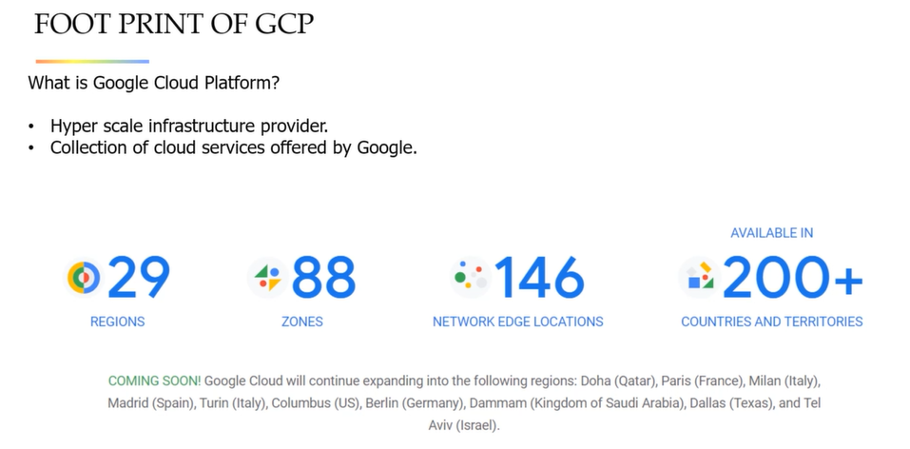

Zones and regions for high redundancy, reliability, coverage and speed

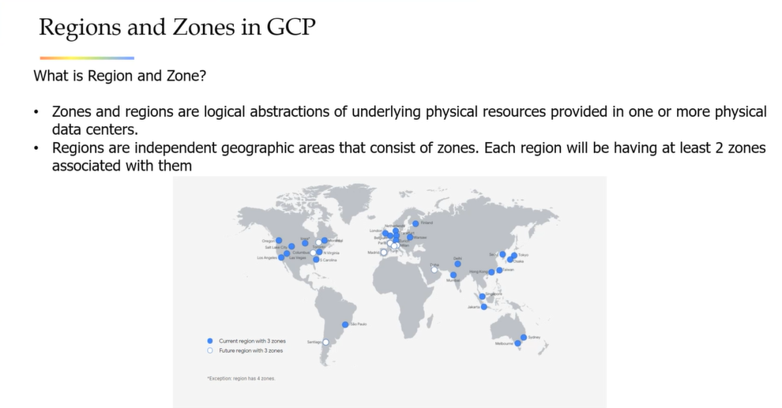

**Cloud computing**

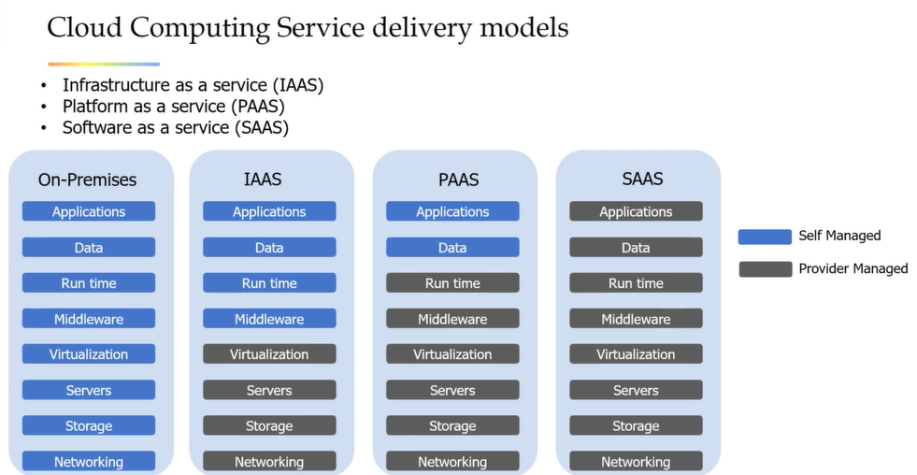

IAAS – Google Compute engine and kubernetes engine

PAAS – Google App engine

SAAS – Gmail

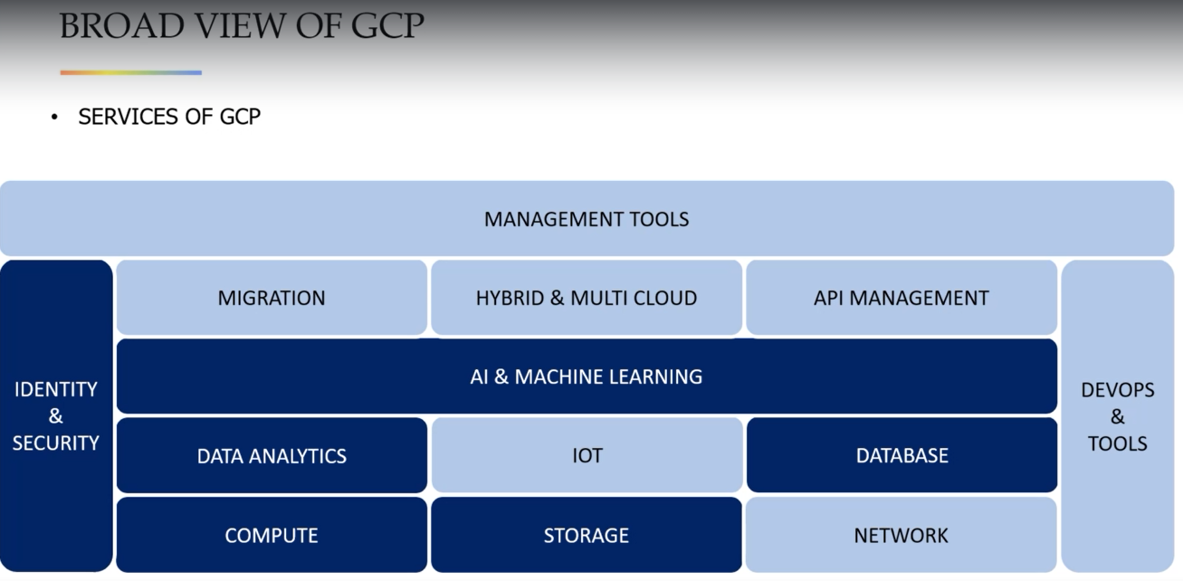

**Hierarchy in GCP**

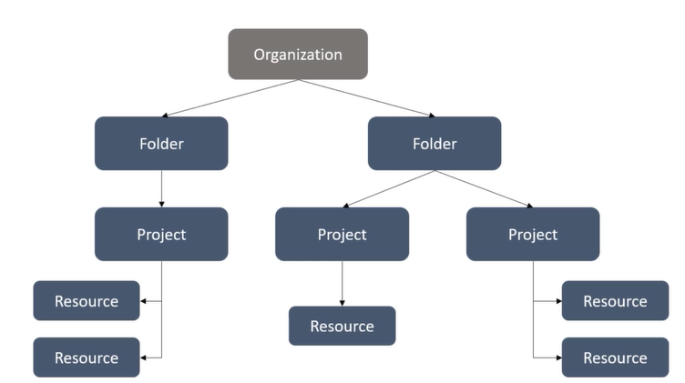

Resource is the fundamental component of gcp like cloud store bucket, VMs and so on.

**How can we interact with these resources?**

By web console – GUI

By command line interface (Cloud shell) – mostly used by devops team. Cloud sdk provides gcloud command line tool which can be used to management dev work flow and gcp resources

By APIs – app apis provide access to services can be integrated with frame works like python; admin apis give functionality for resource manager to build automated apps in gcp

**Compute**

We write ML code and run the algorithms using compute resources.

VM – IaaS . – compute engine

We are moving apart from this concept towards containerization

Kunbernetes – environment for containerized applications

**Cloud function – Function as service. It’s a Server less application**

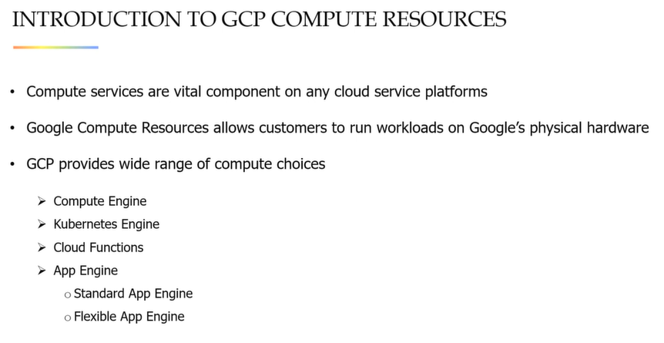

**GOOGLE COMPUTE ENGINE**

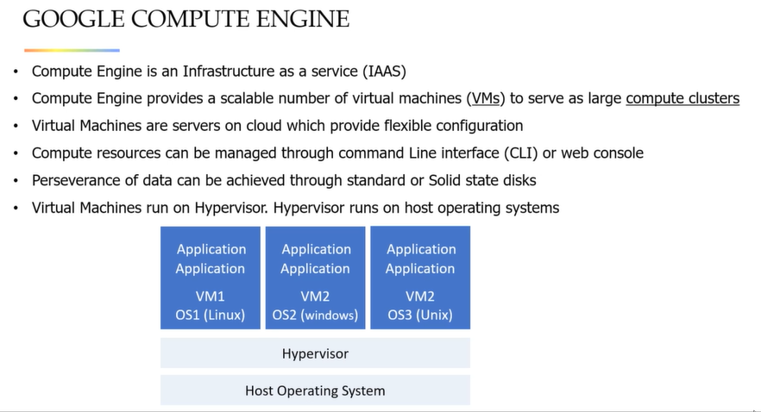

**GOOGLE KUBERNETES**

**Kubernetes – an open source cluster management system to deploy containerized apps**

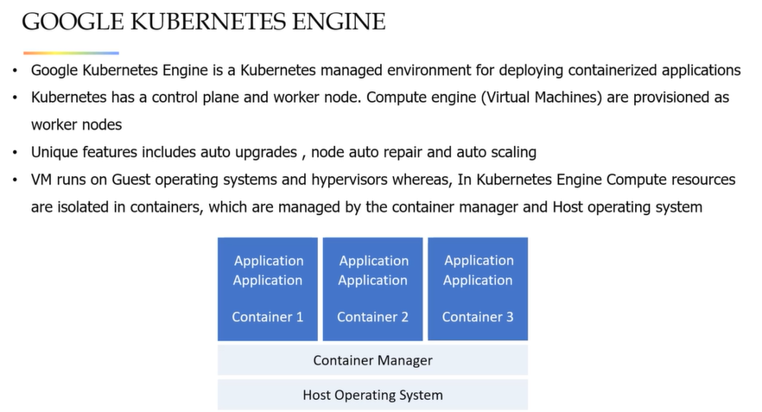

**CLOUD FUNCTIONS**

They remove the work of managing servers, configuring software, updating frameworks and patching OS

Software and infrastructure fully managed by google. User just need to add the code

Cloud functions runs in response to an event. Events are things happened in cloud environment Examples – changes of data in database, new files adding, creating VMs.

A trigger is a declaration that you are interested in a event or set of events. Binding a function to a trigger allows user to capture and act on these events.

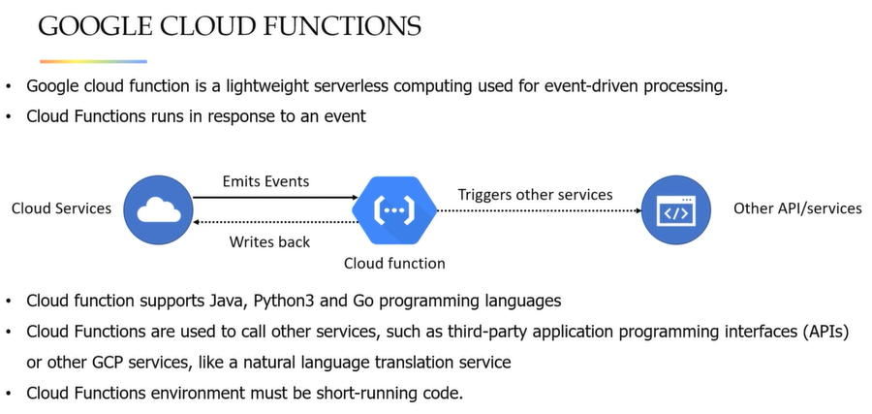

**Google APP engine**

Platform as a service. To build and deploy scalable applications.

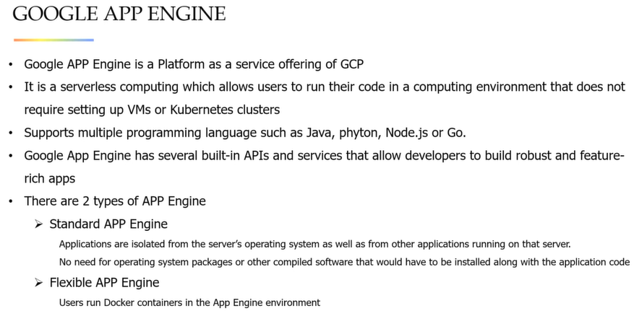

**VMs are very expensive. If you are not using them just delete them to save money. VM creation and access in udemy video**

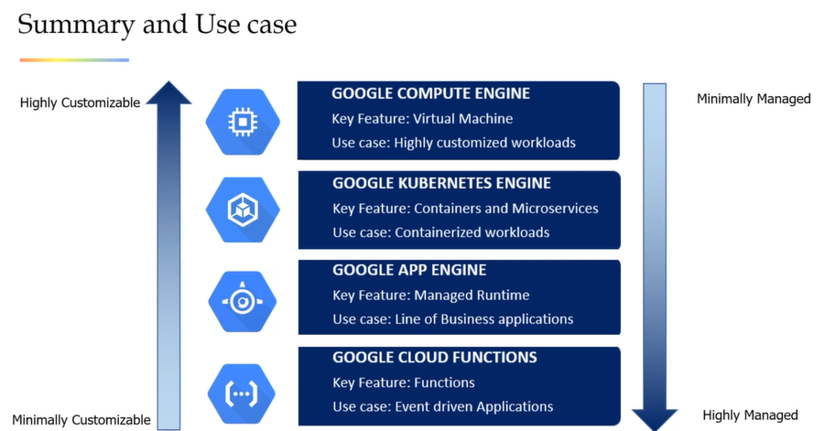

**DATABASES AND STORAGE**

Cloud storage – Object Storing Purpose

Persistent disk – Block strage

File store – For network file storage

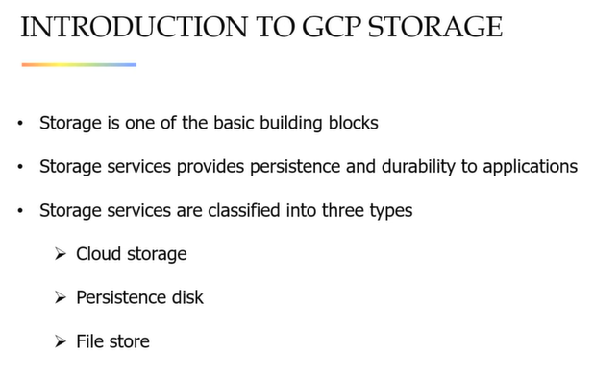

**GCS (Gloud cloud storage)**

Buckets are associated with projects

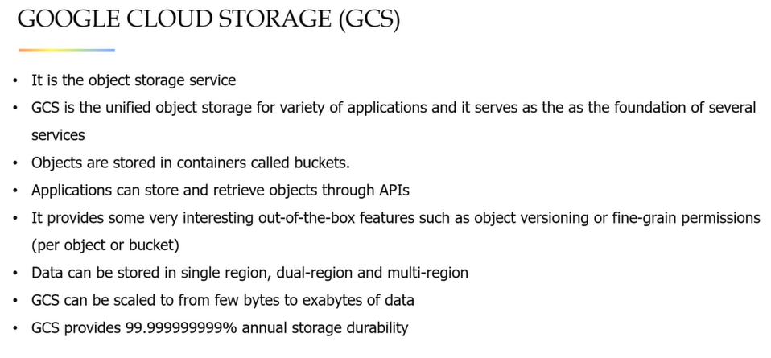

One drawback is data in Object storage can only be accessed via REST api. Designing system and structure file system type cannot be used

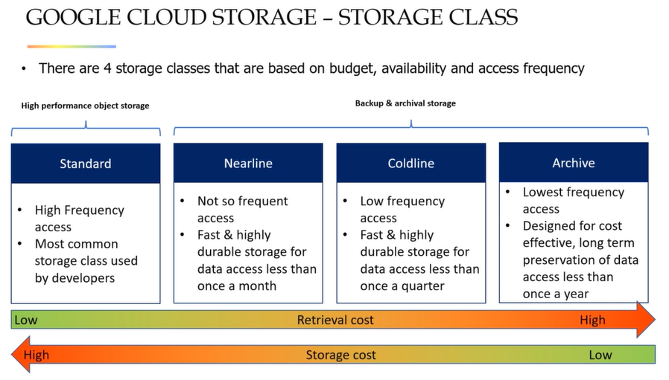

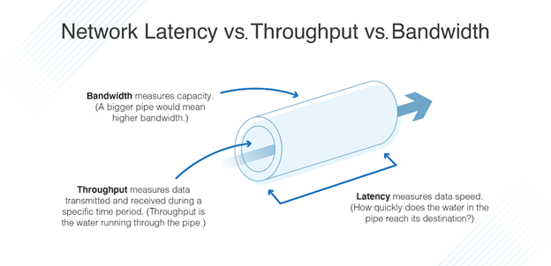

**Persistence disk**

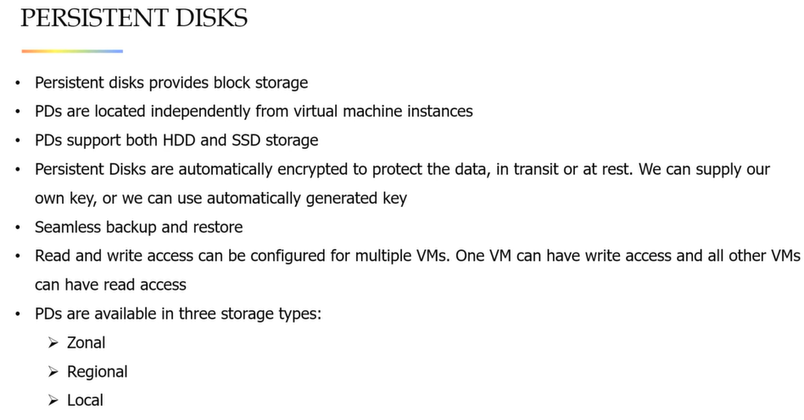

**File Storage**

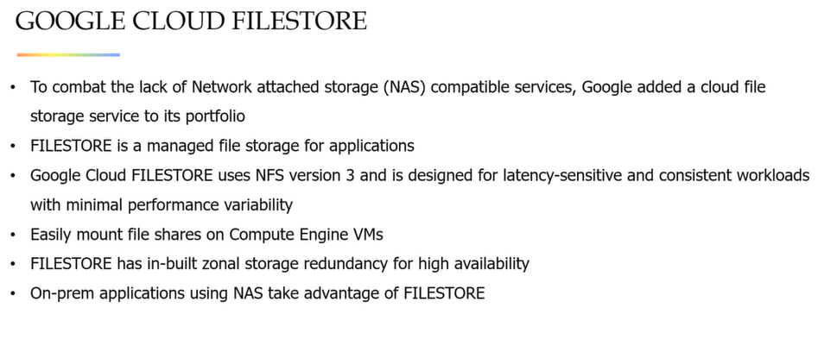

**GCS DEMO AND ACCESS in udemy video. Bucket is building block of GCS.**

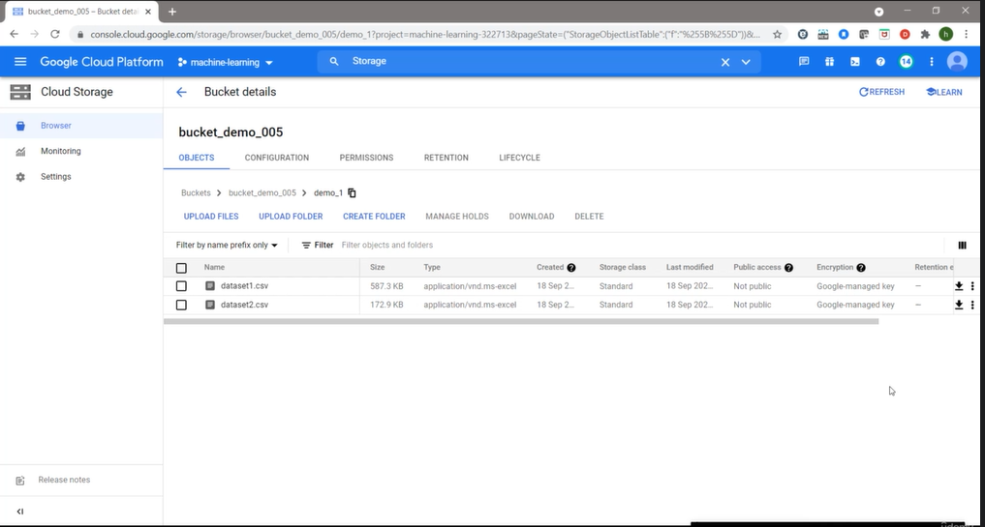

**DATABASES ON GCP**

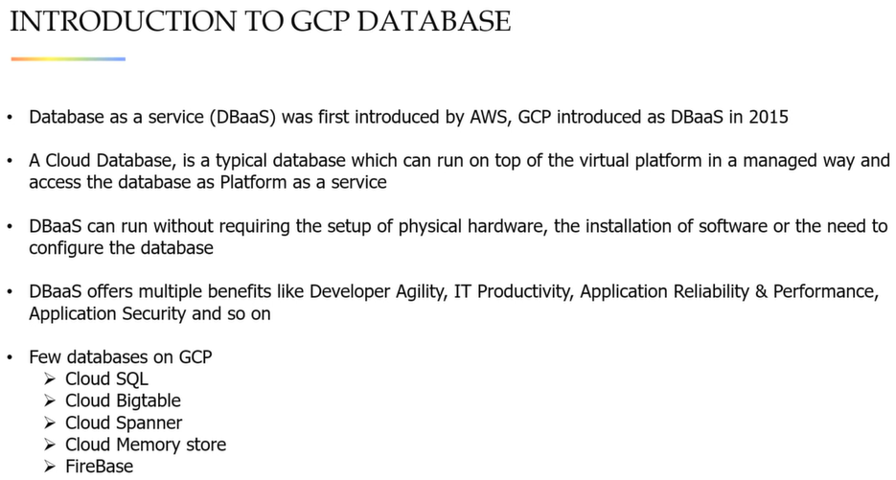

**Cloud SQL**

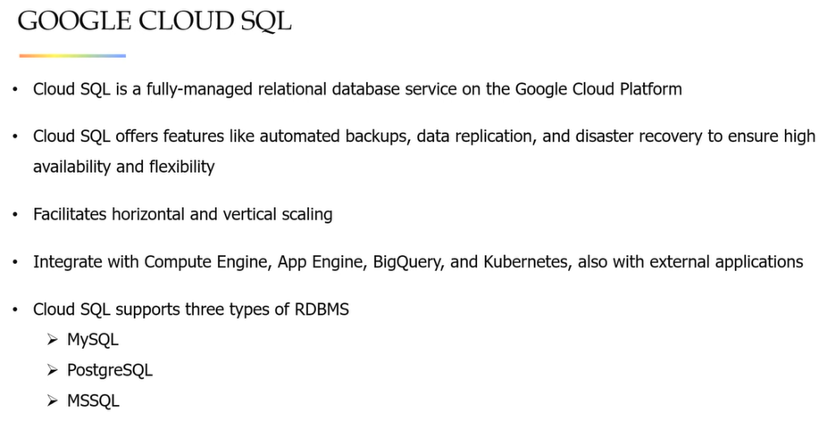

**Cloud Bigtable**

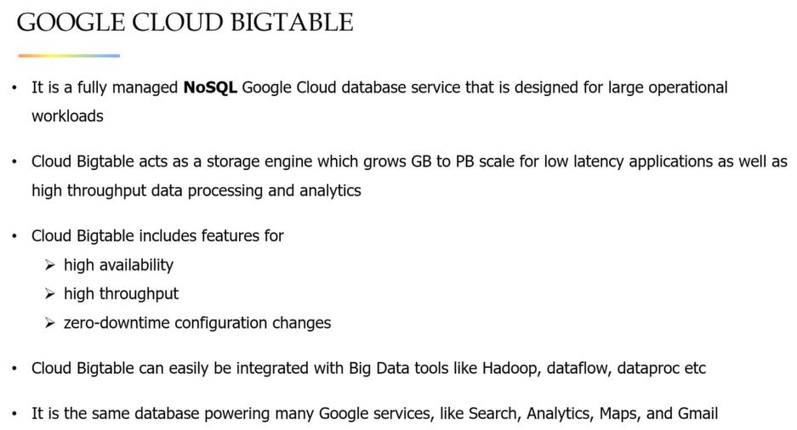

**Cloud Spanner**

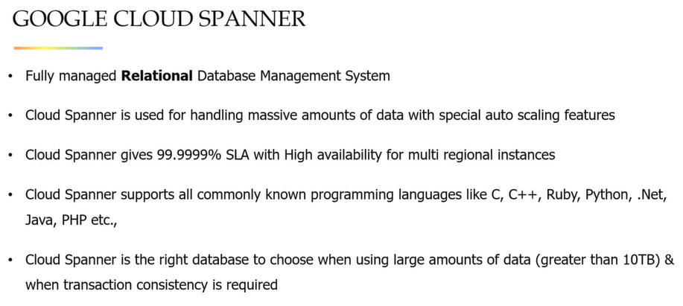

**Google Memory Store**

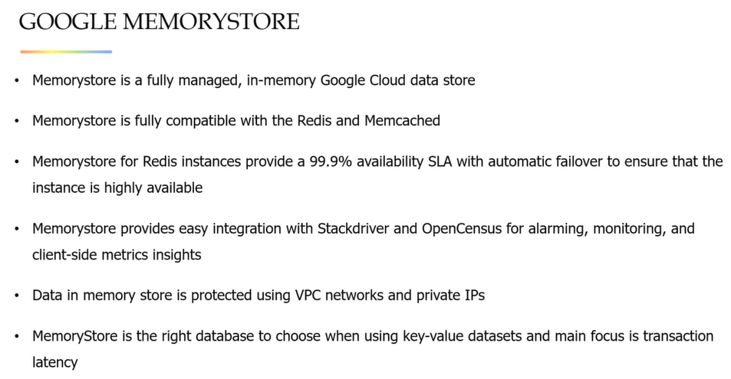

**Firebase Realtime Database**

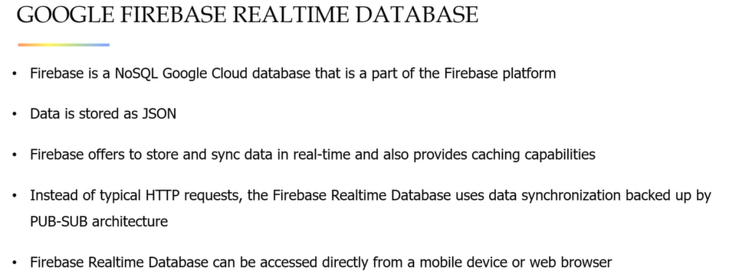

**CLOUD SQL demo in udemy video.**

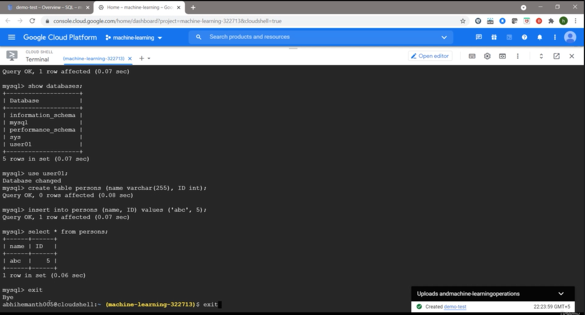

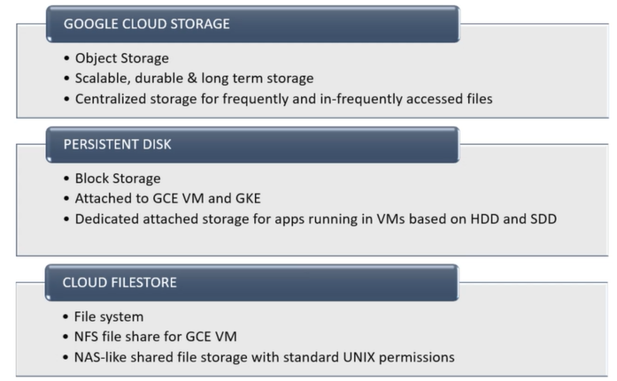

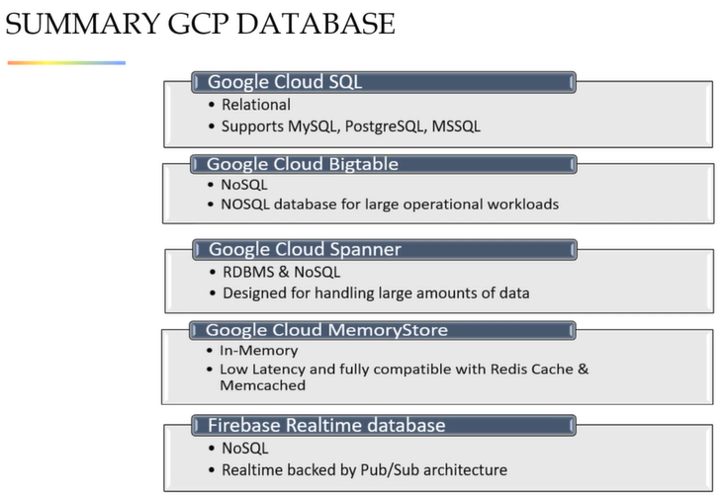

**IDENTITY AND ACCESS MANAGEMENT SYSTEM**

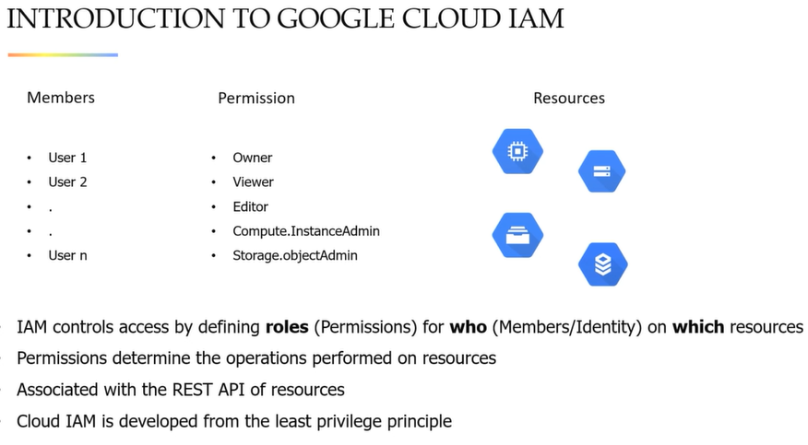

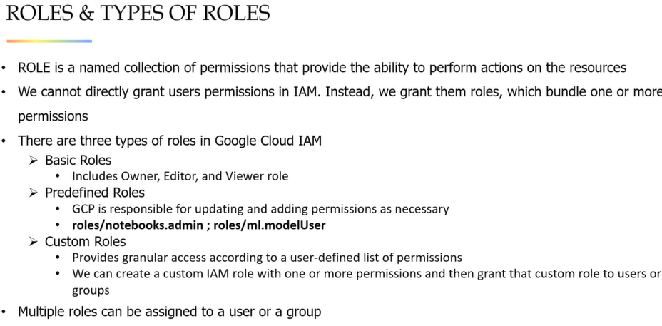

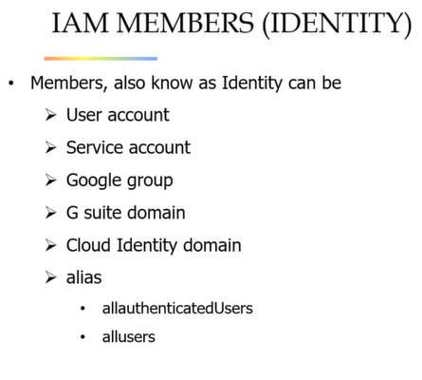

**IAM DEMO IN UDEMY VIDEO. VERY GOOD DEMO. WATCH IT.**

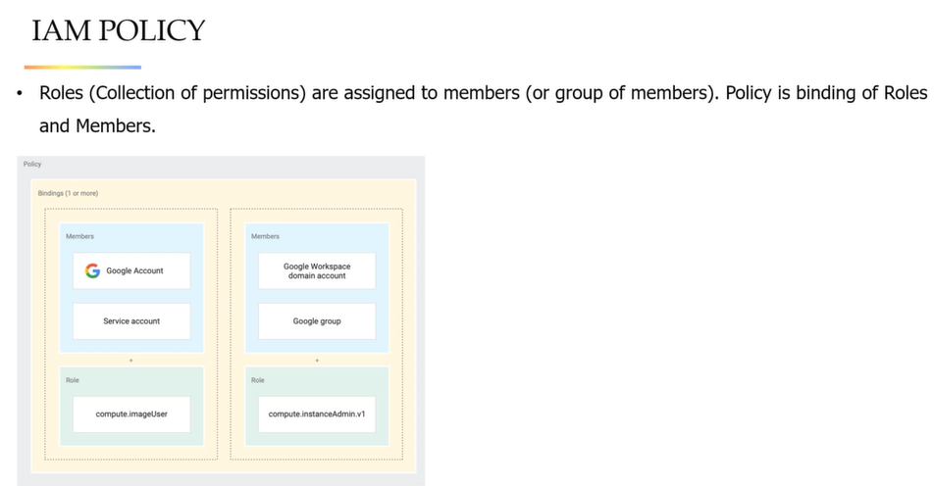

**GCP ANALYTICS**

**Cloud pub/sub** – for streaming analytics and data integration pipeline to ingest and distribute data

**Dataproc** - Fully managed cloud services for simplifying Apache hadoop and spark for deployments

**Dataflow** – processing the data in real time or batch mode

**Bigquery** – enterprise data warehoure which use google infrastructure which enable fast SQL queries

**Dataprep** – cleaning, visualizing unstructured and structured data

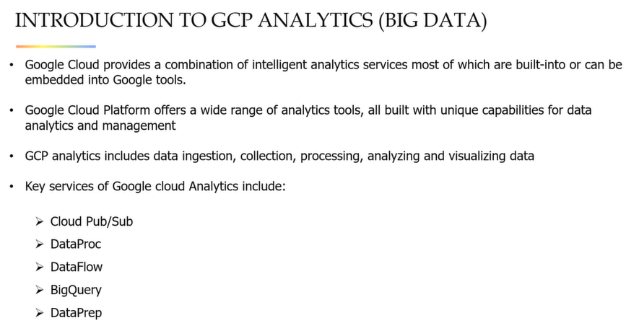

**PUB/SUB – Publishers and Subscribers**

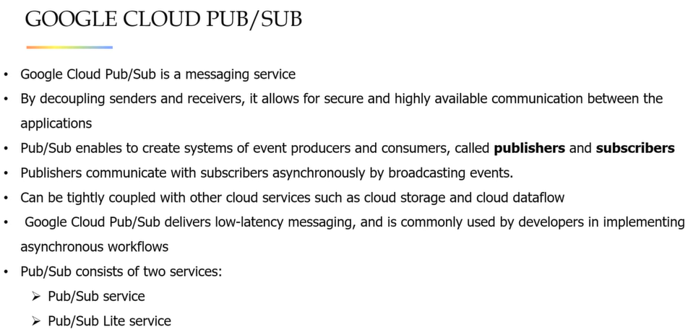

Publisher – application that creates and send messages to topics

Message – A combination of data and some optional attributes which publisher sends to topics and eventually deliver to subscriber

Topic – Named resource to which messages are sent

Subscription – A named resource representing the stream of messages from a single and specific topic to be deliveried to subsctibing application

Subscriber – Application with a subscription to a topic to receive message from it

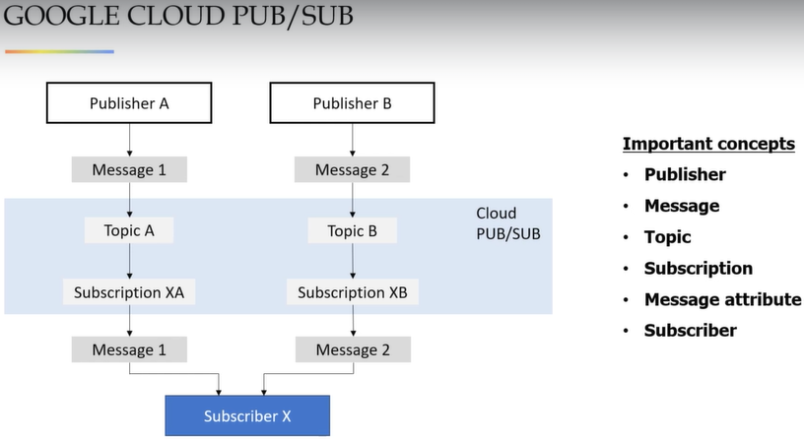

**DATAPROC**

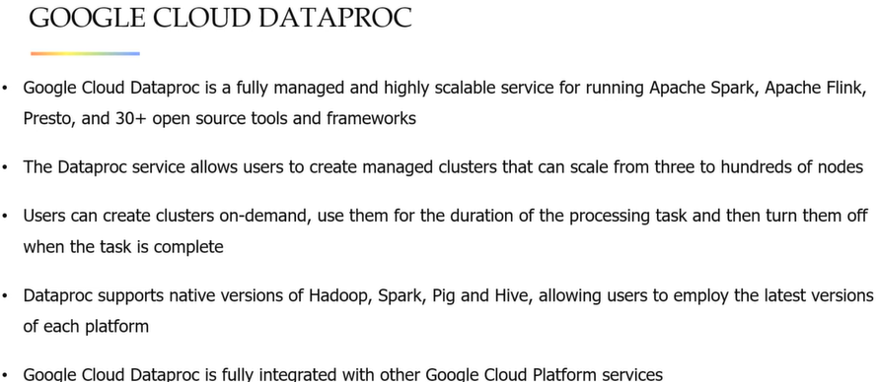

**DATAFLOW**

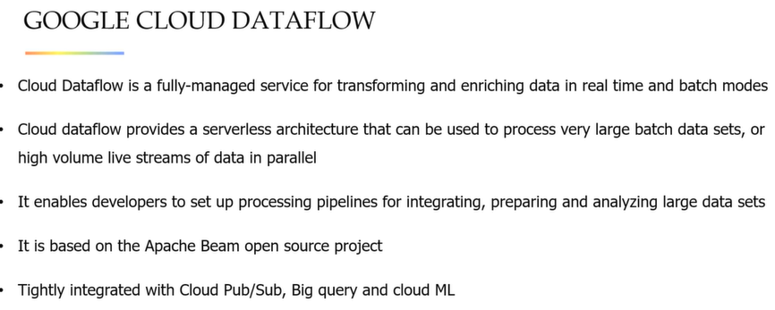

**BIGQUERY**

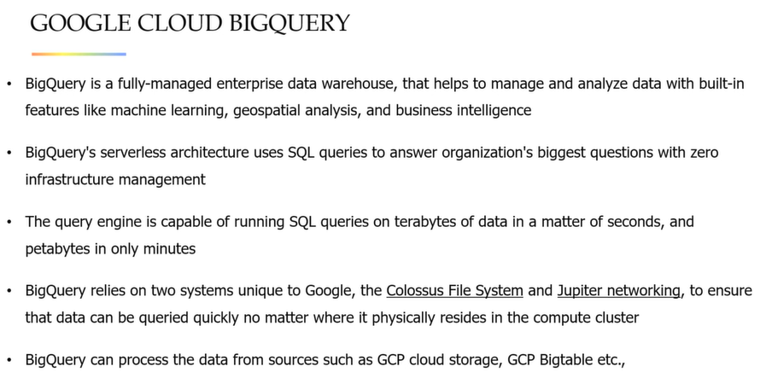

**DATAPREP**

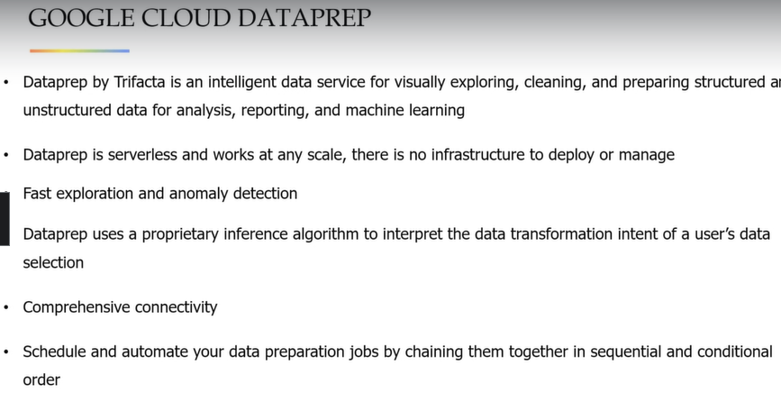

**BIGQUERY DEMO IN UDEMY VIDEO**

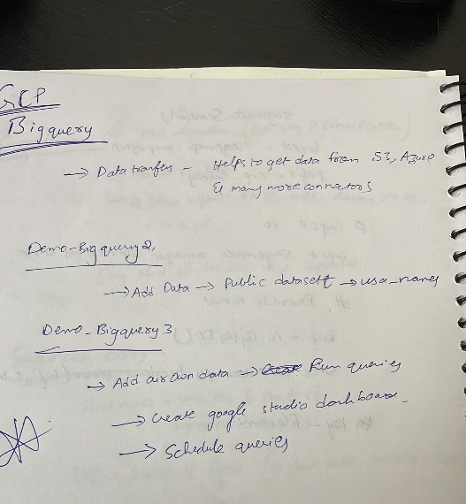

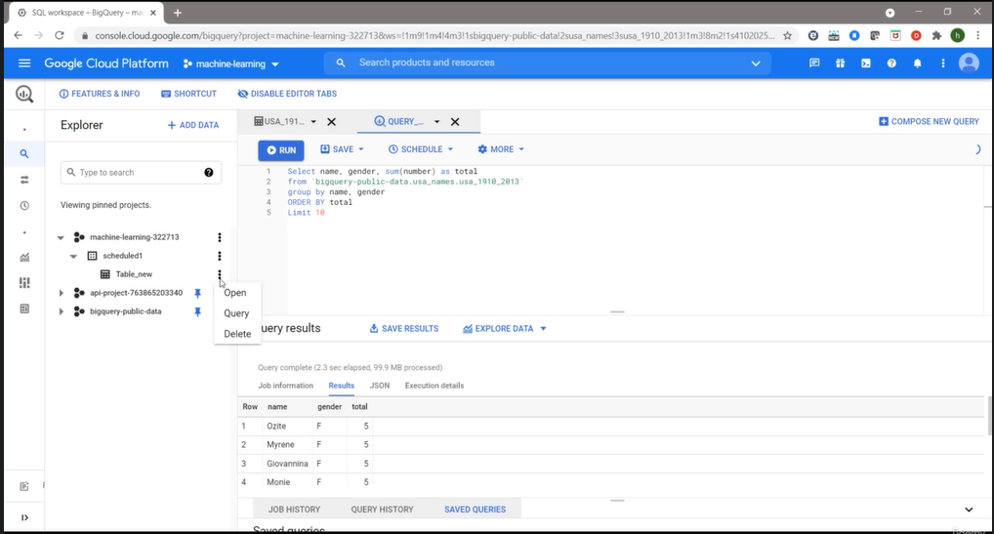

**DATA PREP DEMO in UDEMY**

Flows – to do trnaformation on data

Plans – to combine different flows and run them together

Library – where you can import the data (apis, cloudstorage and so on) by creating connection

Job history – Information about past jobs and we can schedule them as well

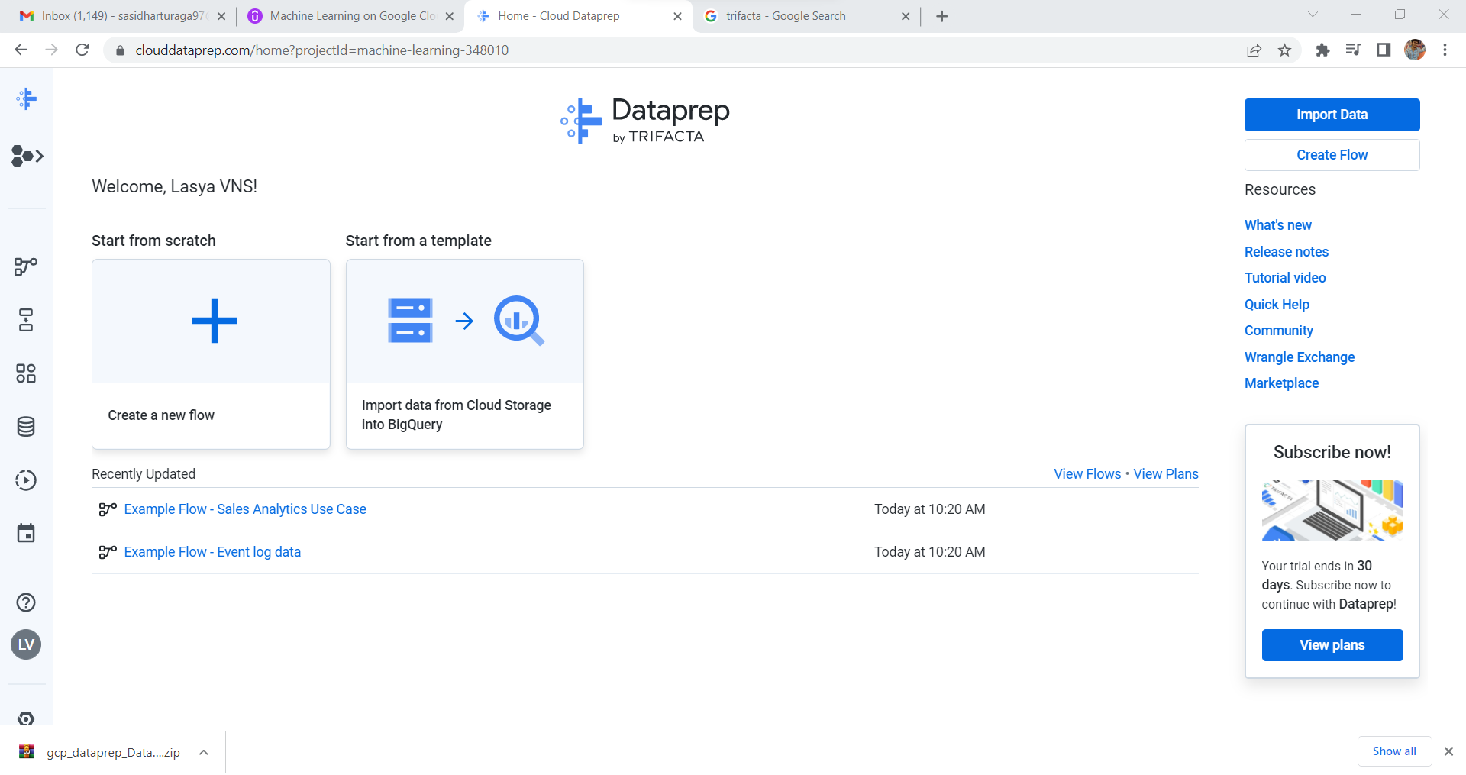

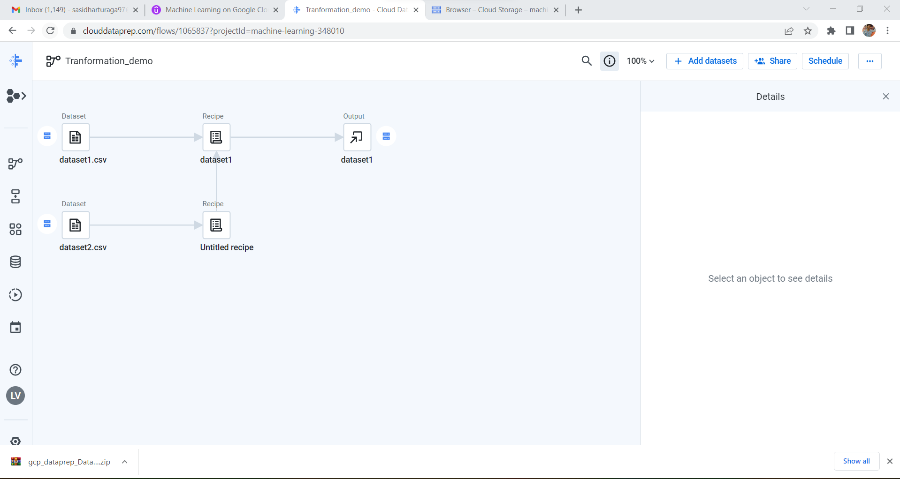

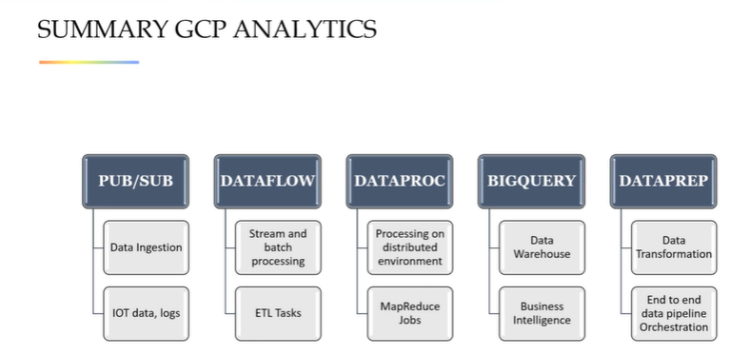

**\*\*\*AUTOML\*\*\***

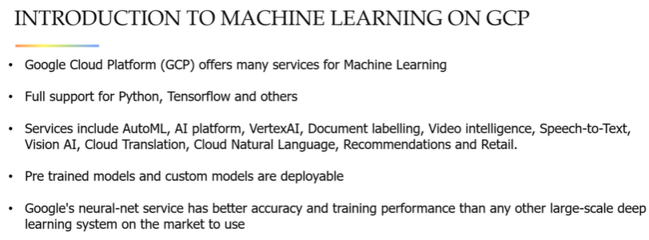

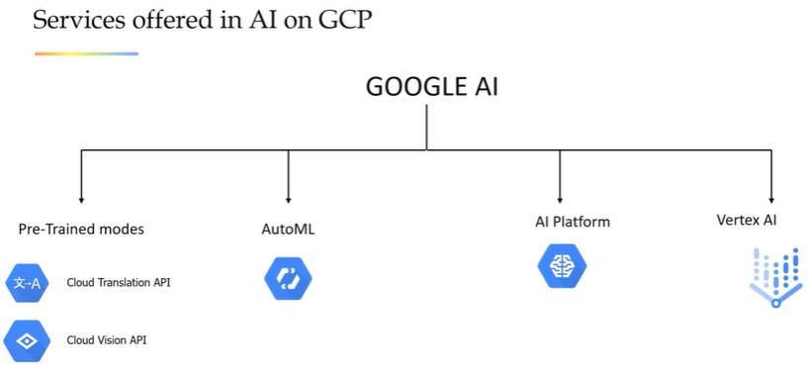

**AUTOML**

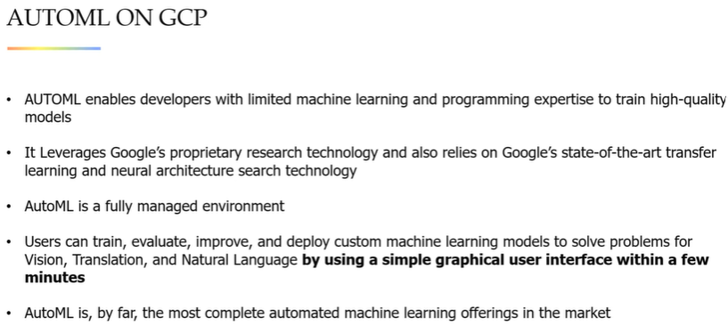

AutoML comparision with custom training of models

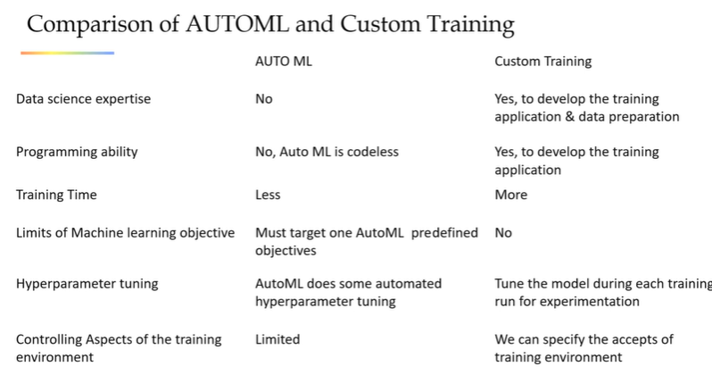

AutoML services

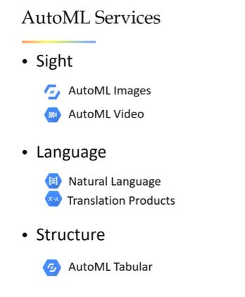

Some feature engineering techniques adapted in feature engineering and model training

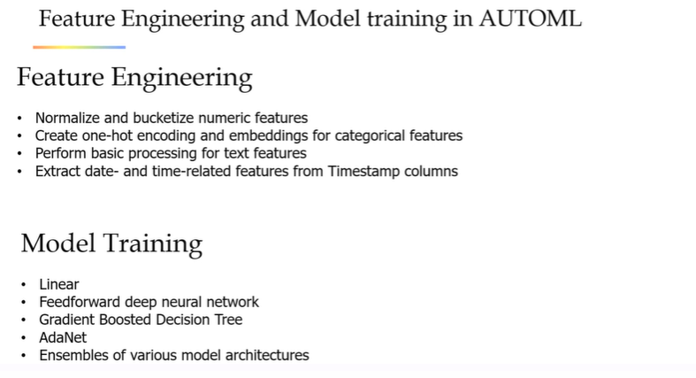

AutoML Tables– Structured data – Car Price predictions

**For AutoML cloud storage bucket location should always be in us-central1 region. It is mandatory**

Type Tables in search -> Open AutoML tables -> Create new data set -> Import data from system/cloud storage ->click on train tab -> make sure all data column types is correct -> select target column -> Specify no. of training hours -> Train the model

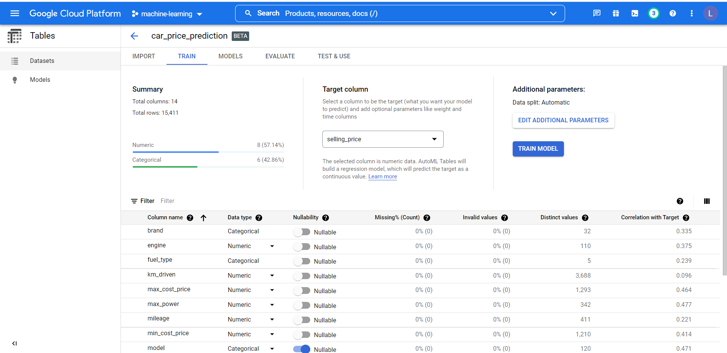

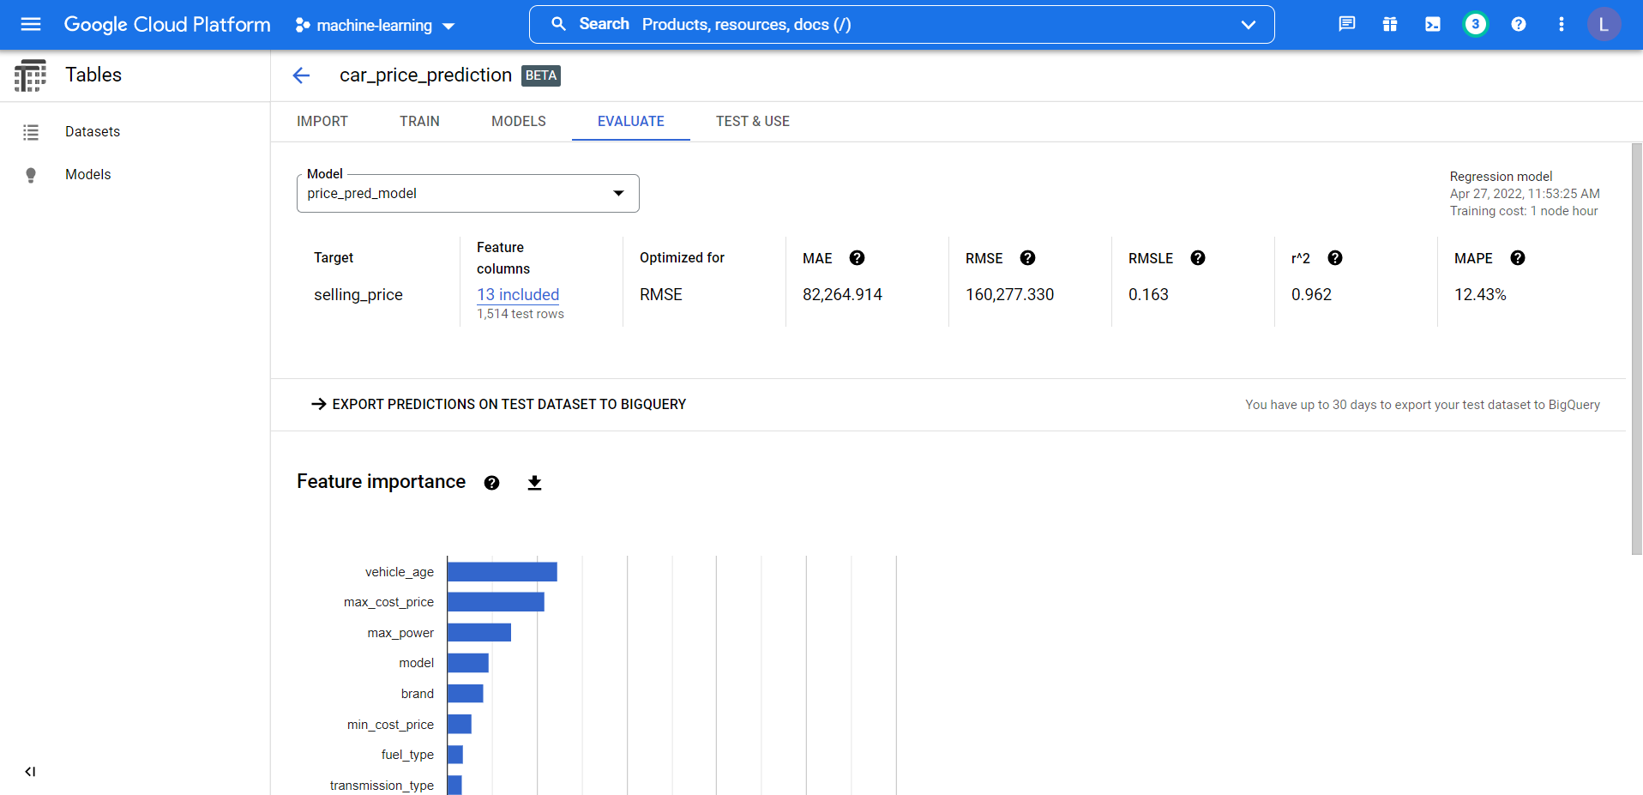

Once its trained on left tab click on models -> Select the model -> Deploy it to predict on test data

WE can do batch predictions without deploying. But for online predictions we have to deploy the model

I HAVE MY FIRST MODEL DEPLOYED IN GCP.

We need to create a service account, generate private key in order to access google api. **Clear details in the video**

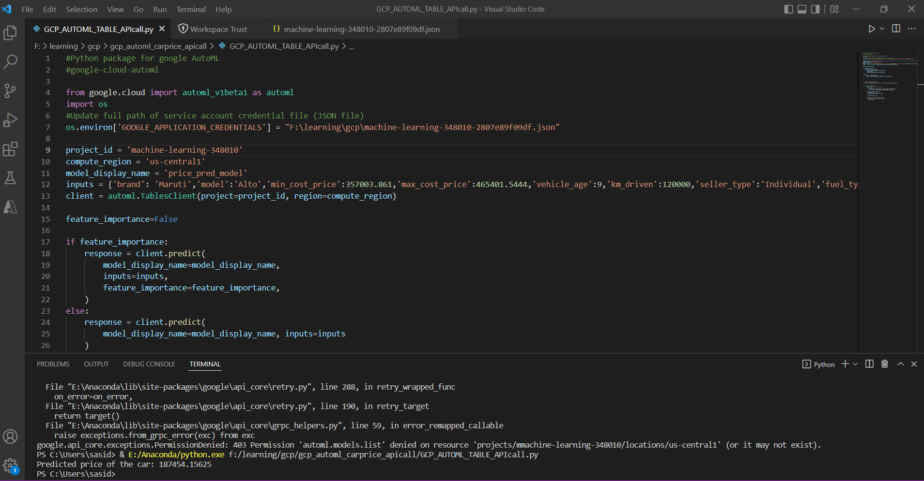

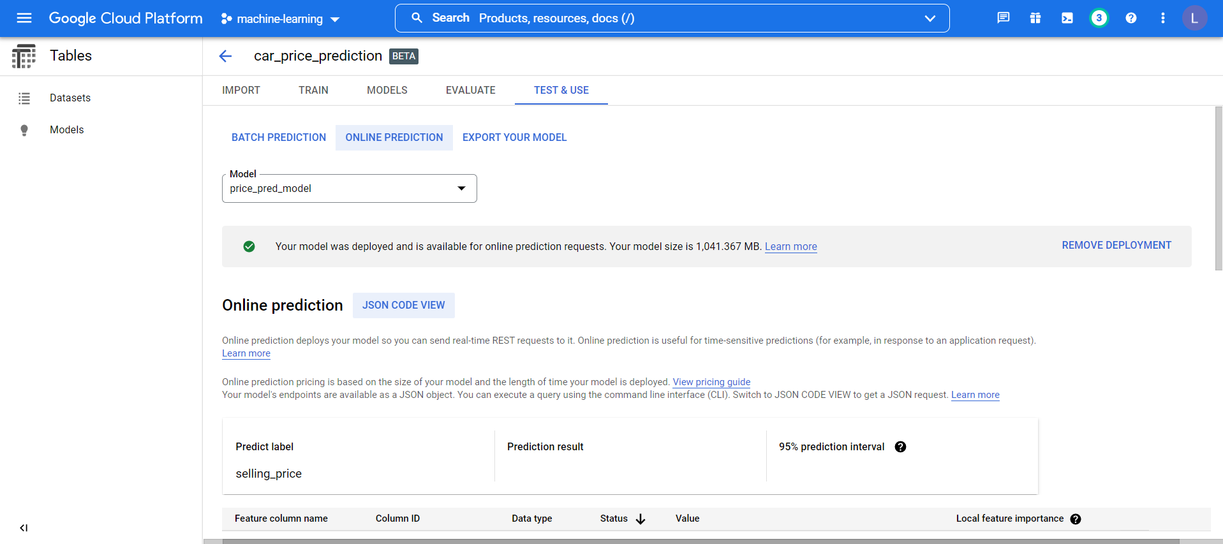

Similarly for AUTOML vision – for images.

As images does not have a target column we have to prepate the data in excel csv.

* Column 1 - Unassigned or train or test indicating where we should use the image
* Column 2 – GCP absoltute paths of image (need to run a console code to obtain all the paths)
* Column 3 – Label

For basket balls images create csv as below

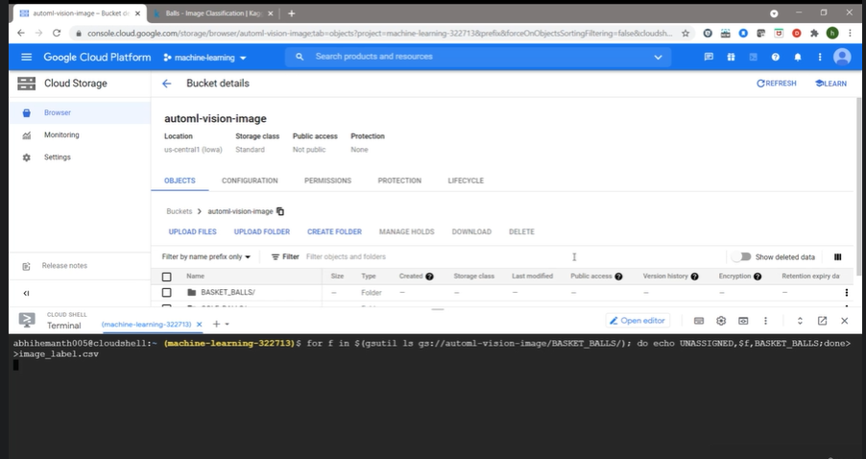

For golf and tennis balls create data and append it to previous csv

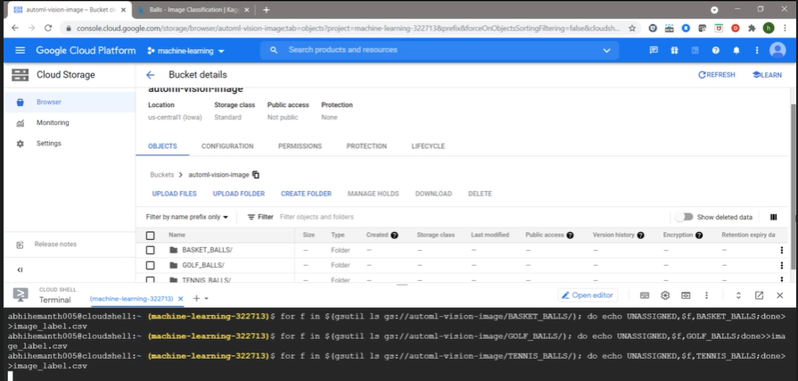

Copy the csv to cloud storage



**Create a new data set -> specify multiclass or multilabel classification -> Open csv file -> Click on images to view each class and image -> Click on train and start training -> Keep it cloud hosted (edge device option is also available)**

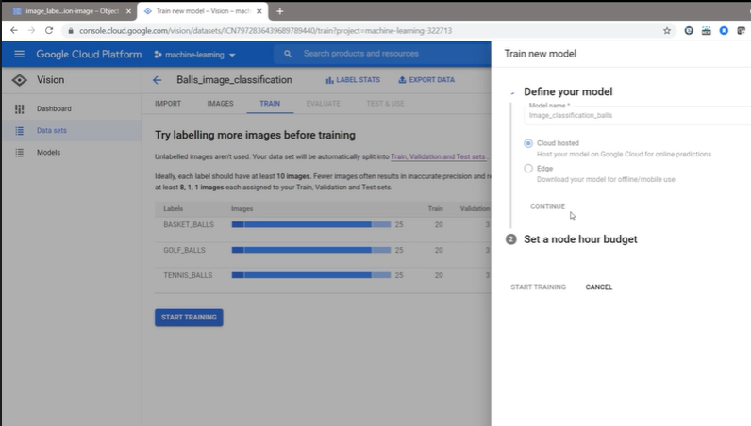

Evaluate

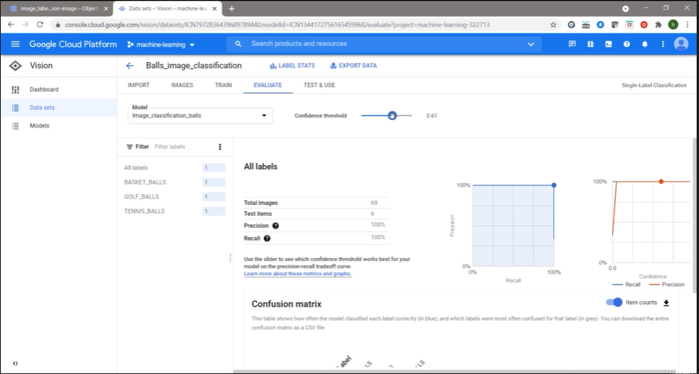

Deployment – No option of batch prediction like tabular data. Only online prediction available for images

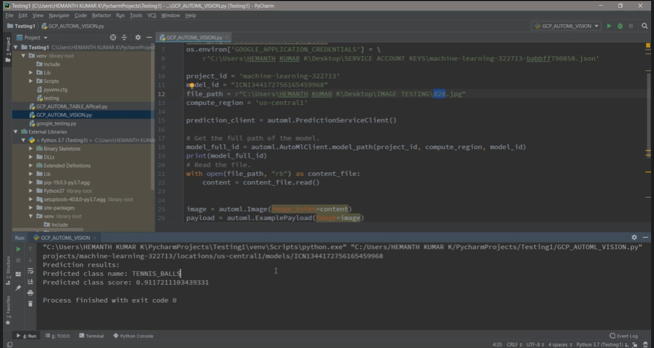

**AUTOML TEXT ALSO FOLLOW SAME PROCEDURES AS AUTOML VISON**

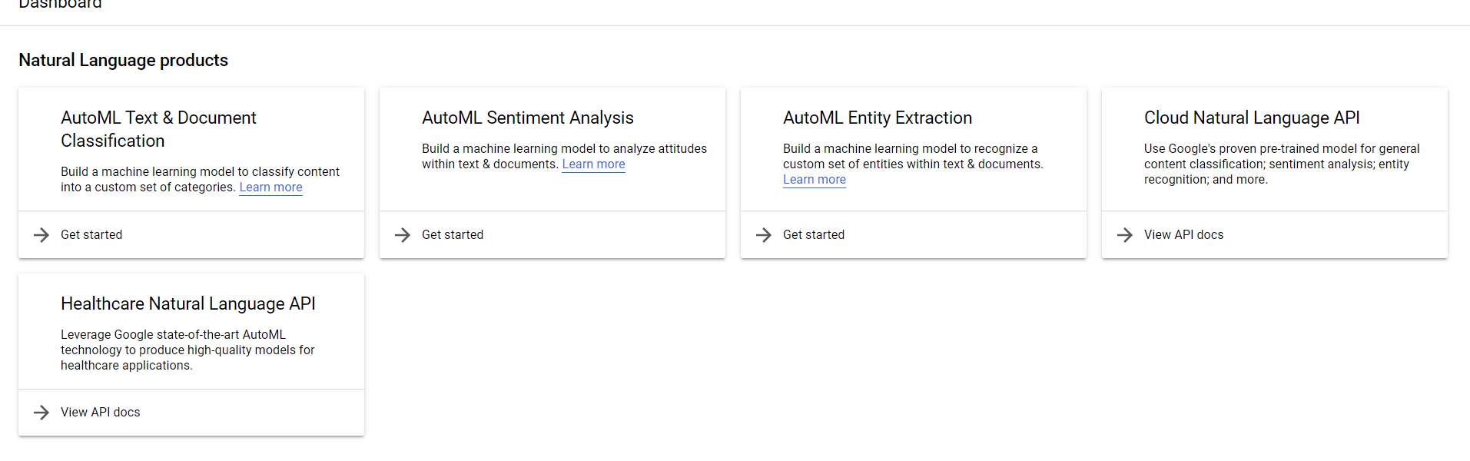

**AUTOML pre-built models – Experiment with NLP api**

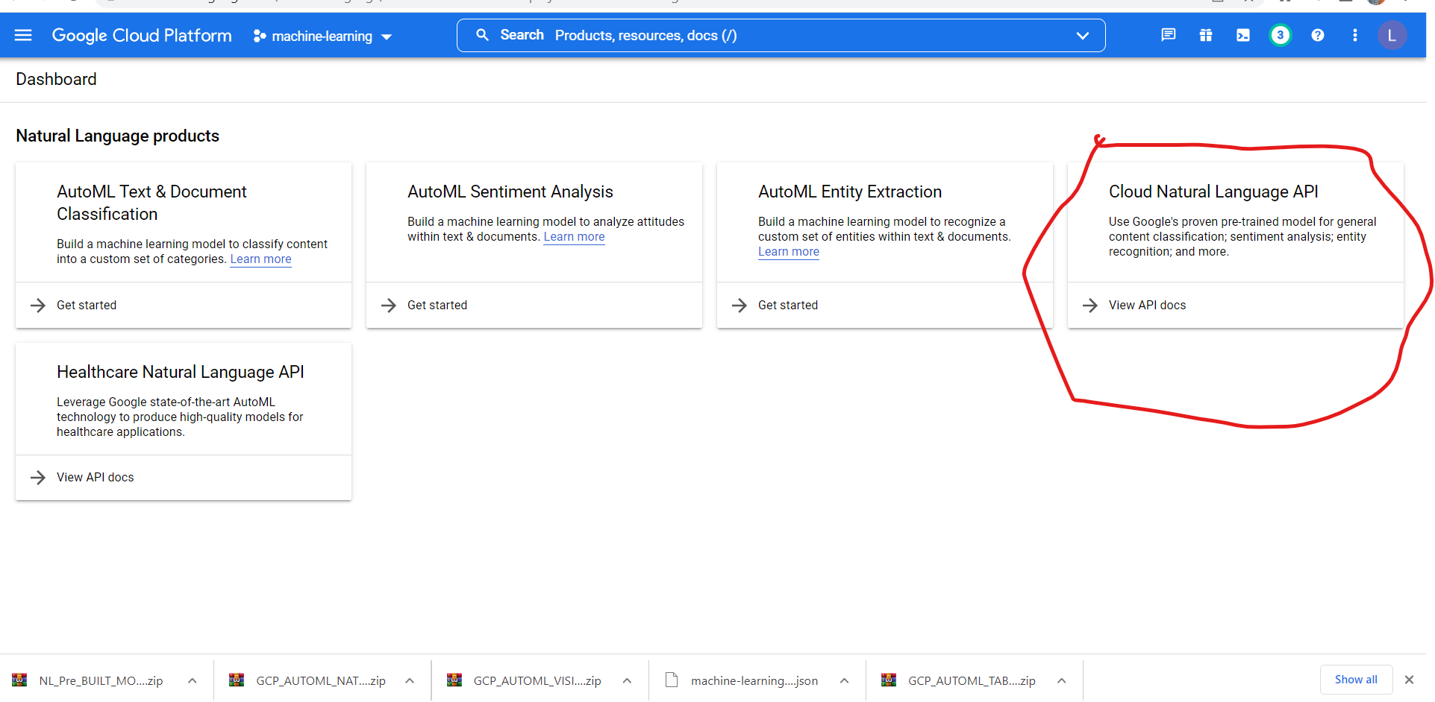

**All we have to do is run the below python code. In order to executte it we must enable API and services.**

**Click on API & Service on left menu of GCP -> on top click on “+ENABLE API AND SERVICES” -> search for “Natural Language” and enable it.**

**We can use same Service account we used in AutoML table as we have given access to entire project. Run below python code to get predictions**

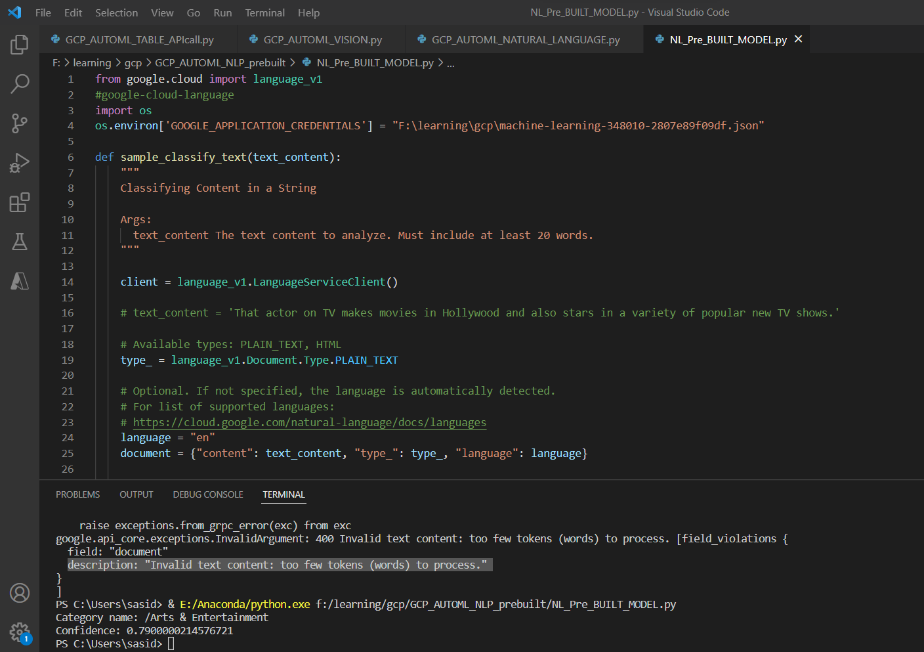

**Above mentioned code is for CLOUD NATURAL LANGUAGE API only and for text classification.**

Each and every task of NLP and vision API have different codes and steeps – **ALL THE codes and instructions are available in GCP website links**

<https://cloud.google.com/natural-language/docs/how-to>

<https://cloud.google.com/vision/docs/how-to>

3 steps – Service account and credentials, Enable API and get relevant code from docs…. USE THE APIS to rock the world

**AUTOML SUMMARY**

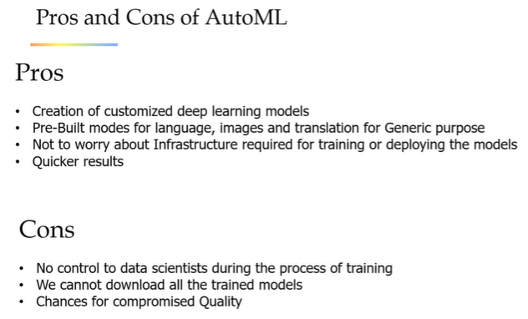

**AI PLATFORM**

Comprehensive platform – where we can access the data from cloud storage, big query, apis – where we can code in Jupiter notebooks to develop and deploy

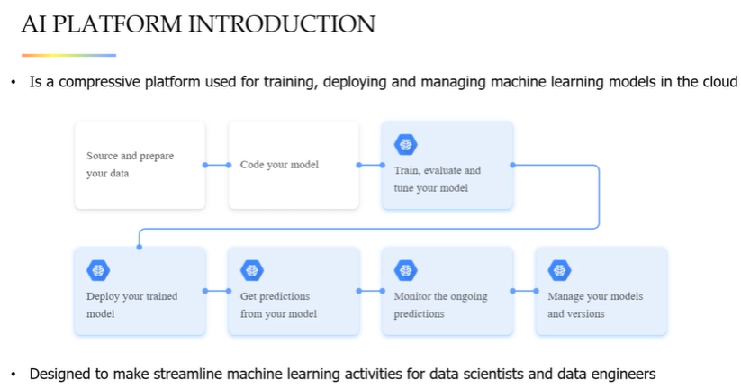

It have different components as follows

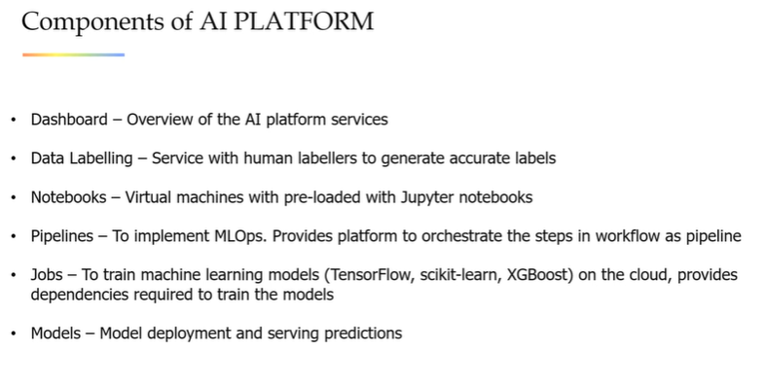

**AI platform – hands on**

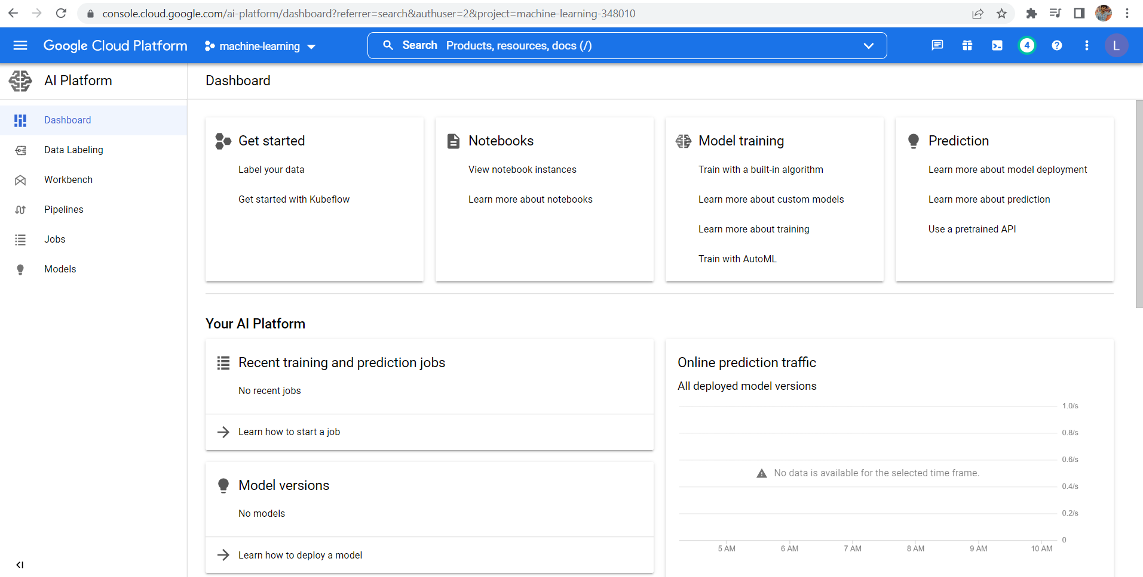

Notebooks have been completely moved to vertex AI

**Vertex AI -> Workbench -> Create notebook -> Select region, configuration and so on -> Create instance -> User managed notebooks -> Open jupyterlab**

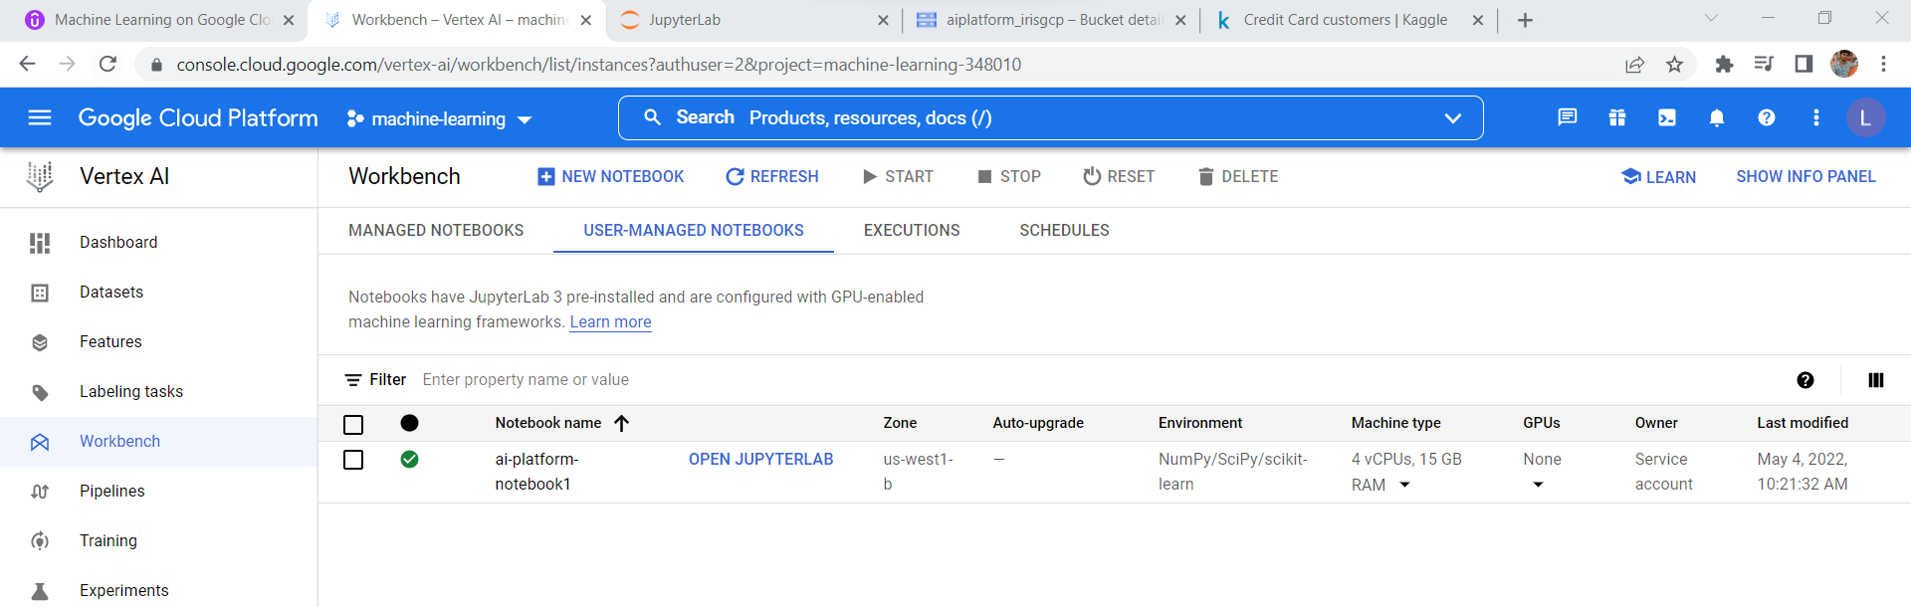

We can load the code from scratch or we can pull it from Github or we can upload it from our systems

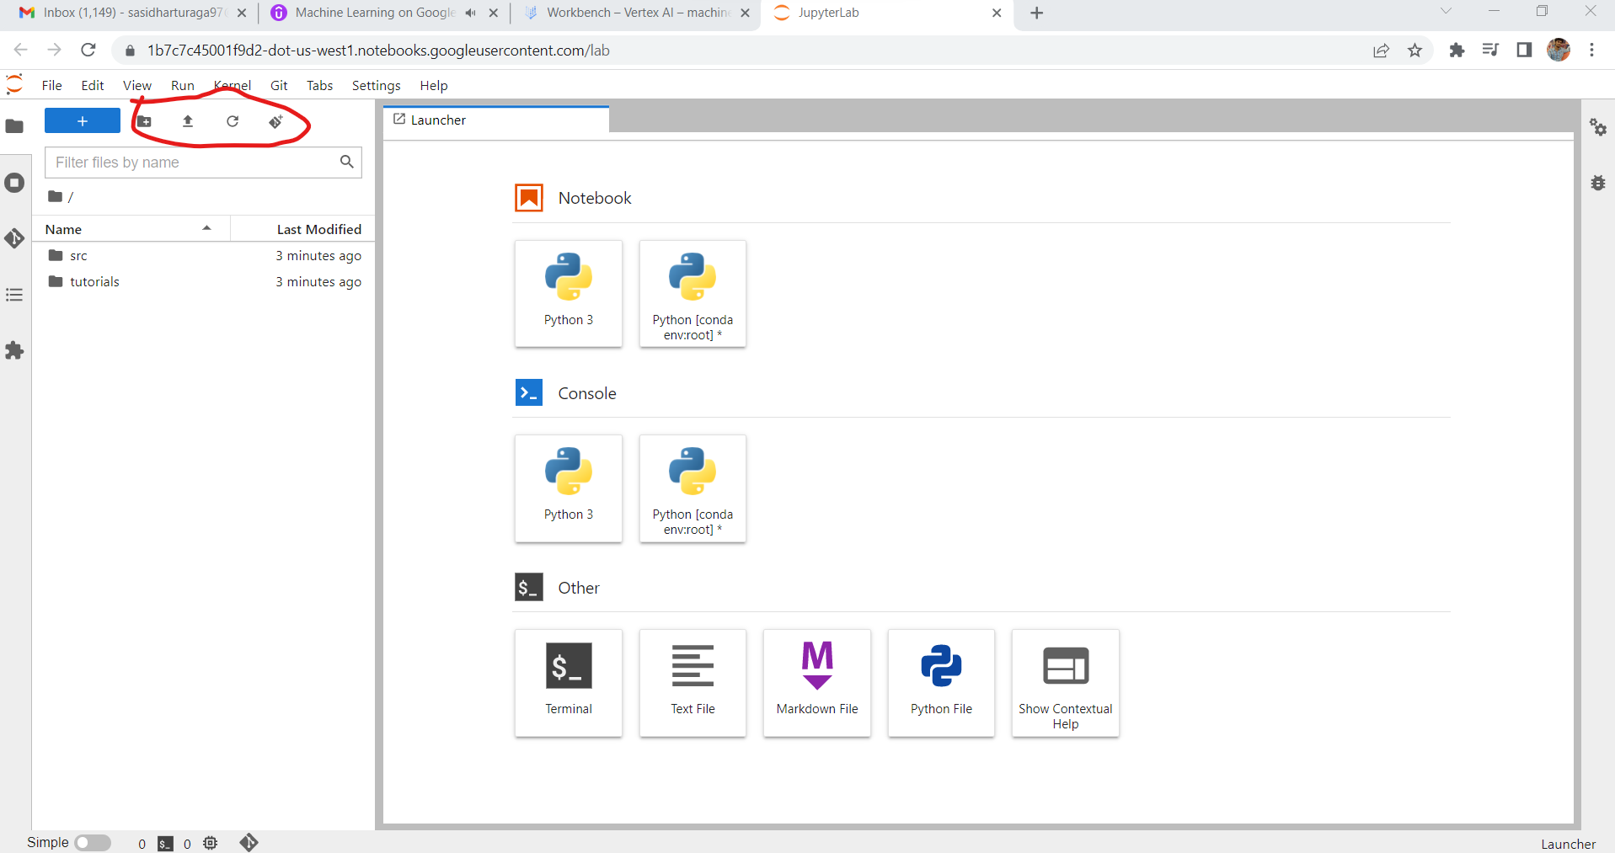

We can pull and push codes in and out of Github with the help of git

**Run the jupyter notebook and save the model as joblib file in the cloud storage -> Refer to GCP_AIPLATFORM_IRIS-main folder**

**Deployment**

AI platform -> left tab “Models” -> Create Model -> Enable logging and open it

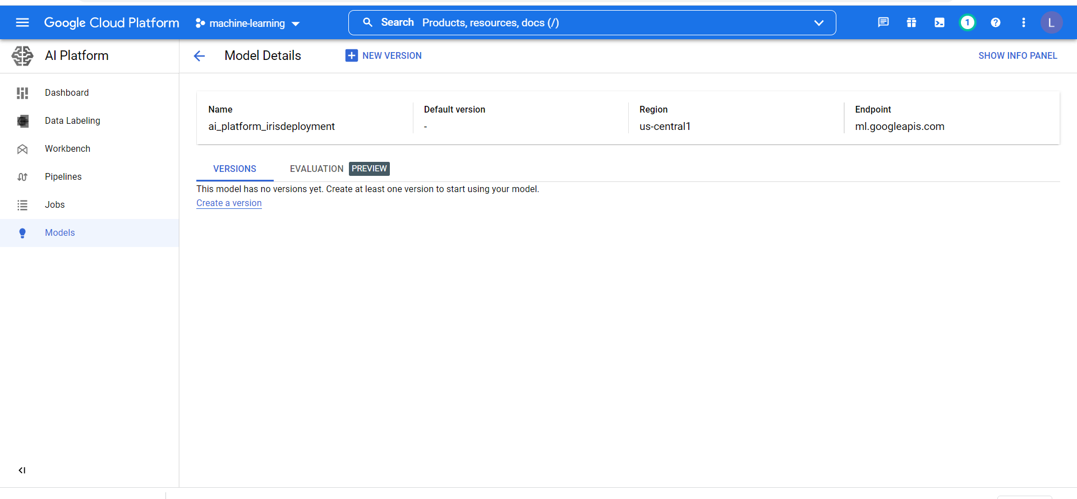

Create a model version -> from pre-built container -> Slect version of python sckitlearn, run time and so on -> slect the folder where our model resides (either joblib or pickle files)

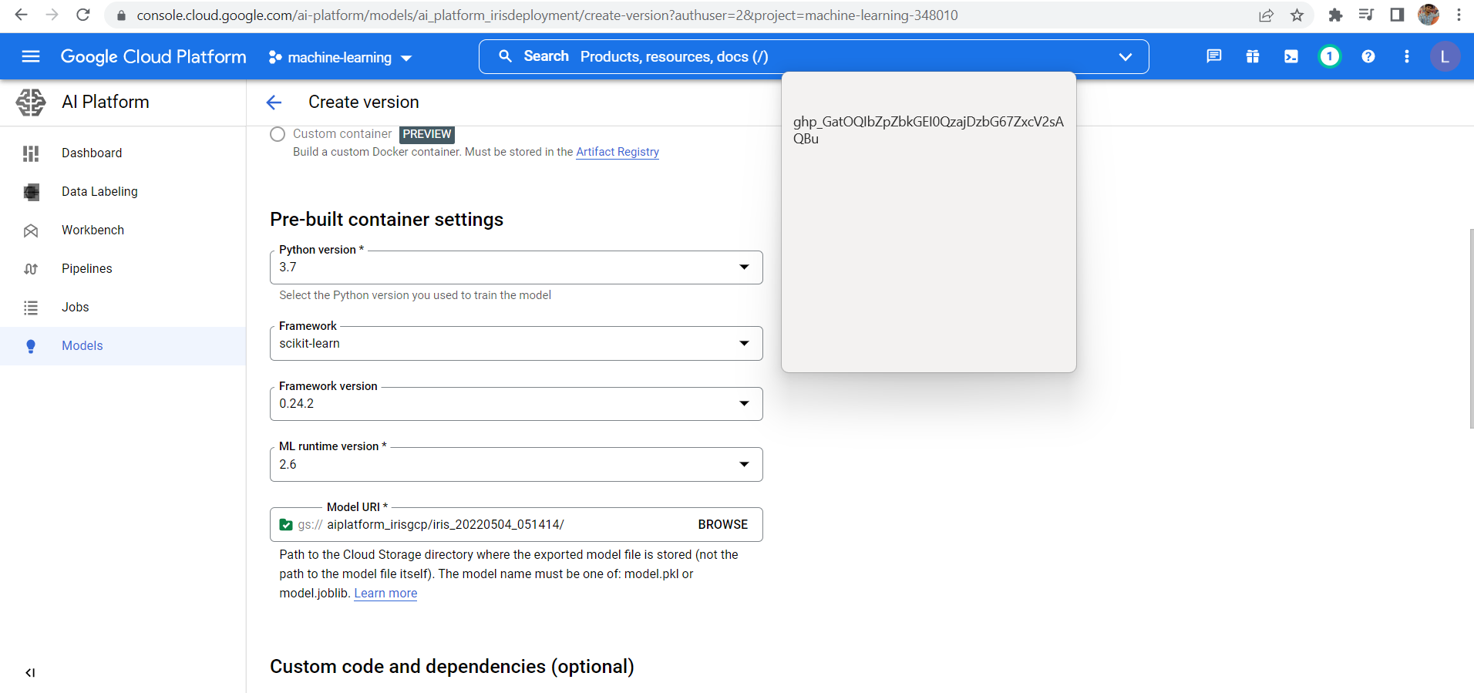

A model can have multiple version and we can associate the service account for online predictions as well.

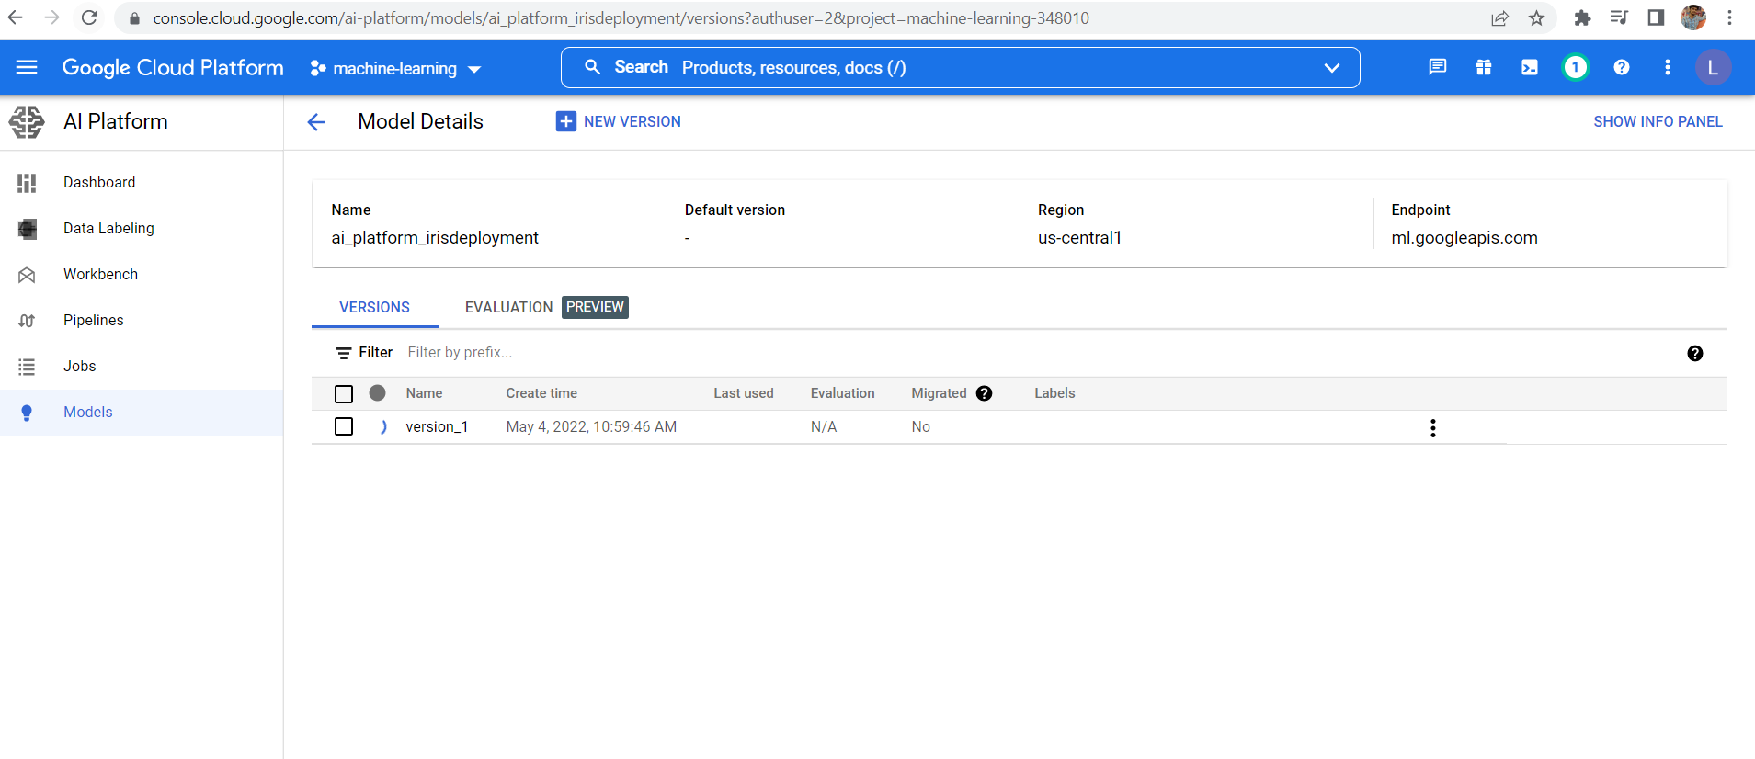

After deploying the model- we can test it, we can make the prediction only on json format.

{instaces : [[list1],[list2],…]} Predicted result for each test result will come below

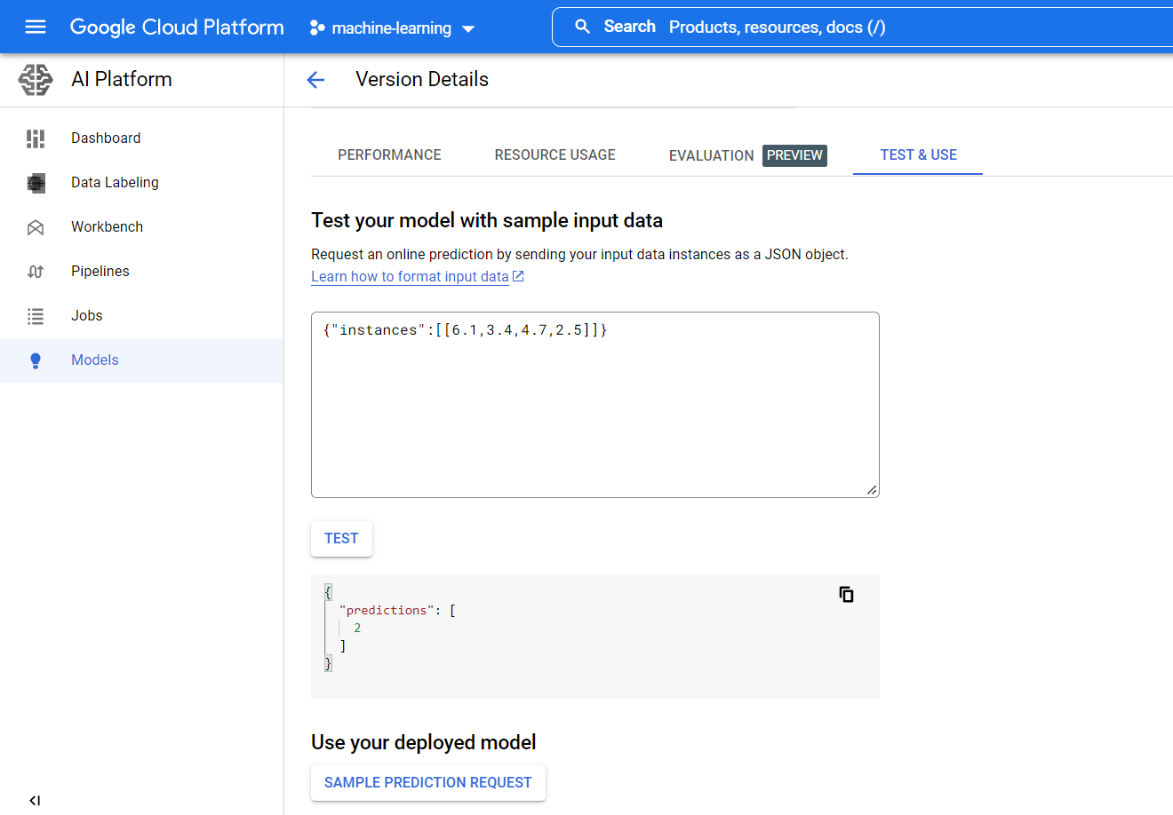

Predict it locally using this

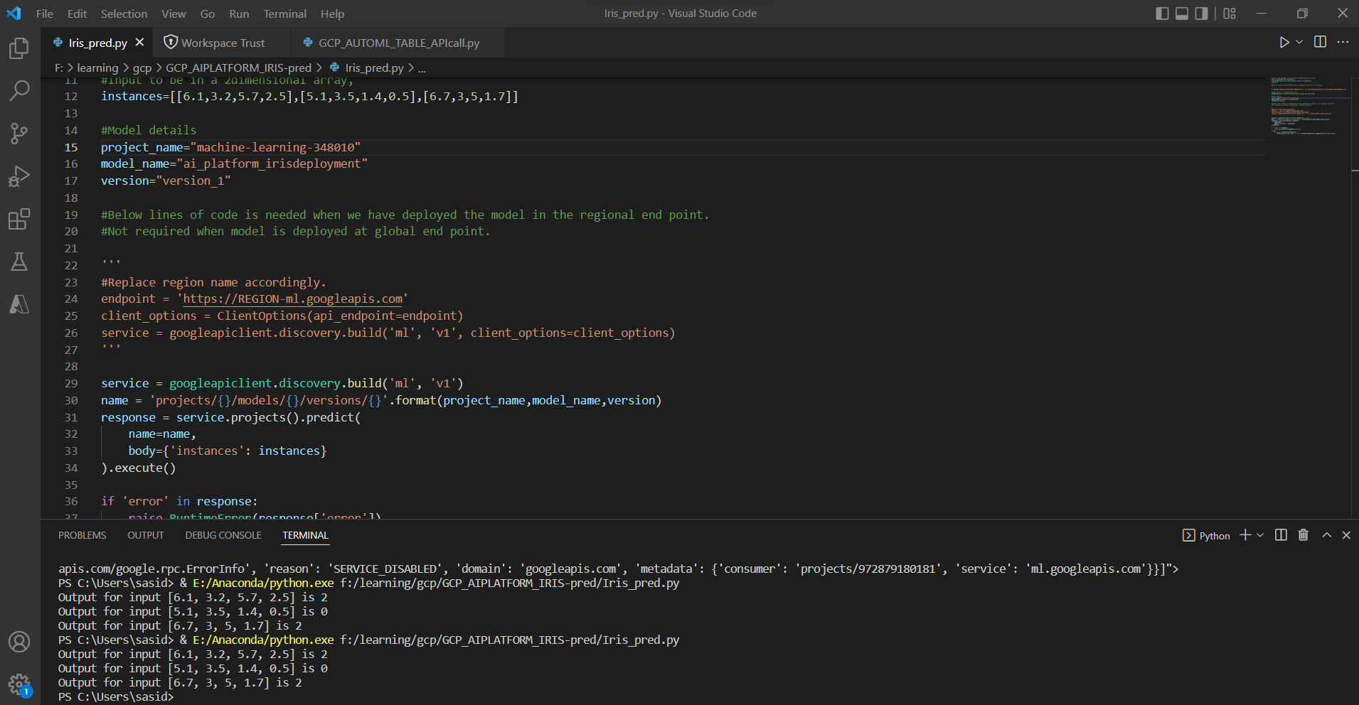

**AI PLATFORM custom predictors**

If we have our model built upon any other packages other than sckitlearn or xgboost or tensorflow, we cannot deploy directly. We have to package the model and give all the dependencies & requirements. This method is referred as customer predictors

To built Scikit learn pipelines as well we need to build custom predictors

Get bank churner data from kaggle -> save it in gcp learning folder -> upload it into cloud storage bucket -> open ai platform -> workbench -> **create a notebook instance in us-central region ->** Upload the notebook from folder or pull it from Github

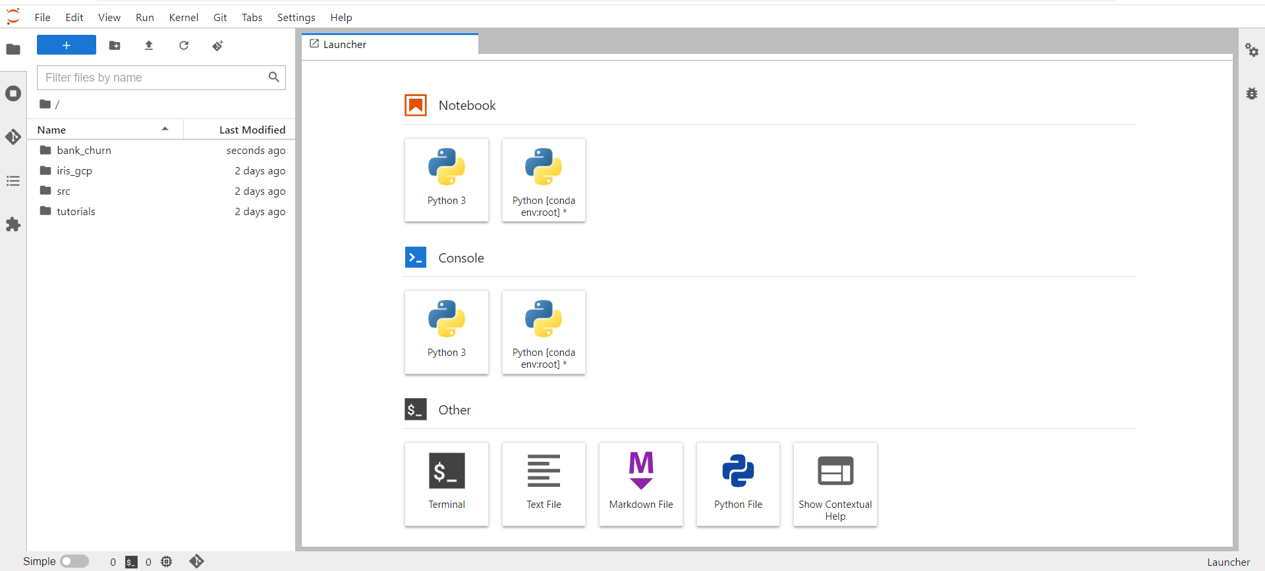

Install required packages from terminal

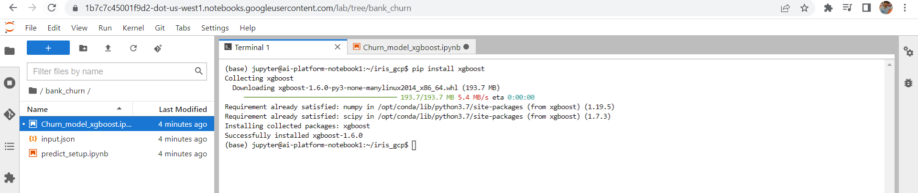

**Run the code in the notebook –**

**PIPELINES refer to THE NOTEBOOK 🡪 Churn_model_xgboost_gcp_pipeline**

ONE OF THE BEST CODES WRITTEN – reading and modyifying data -> creating data pipelines -> adding ML algorithm -> train and test and save the model in the cloud bucket

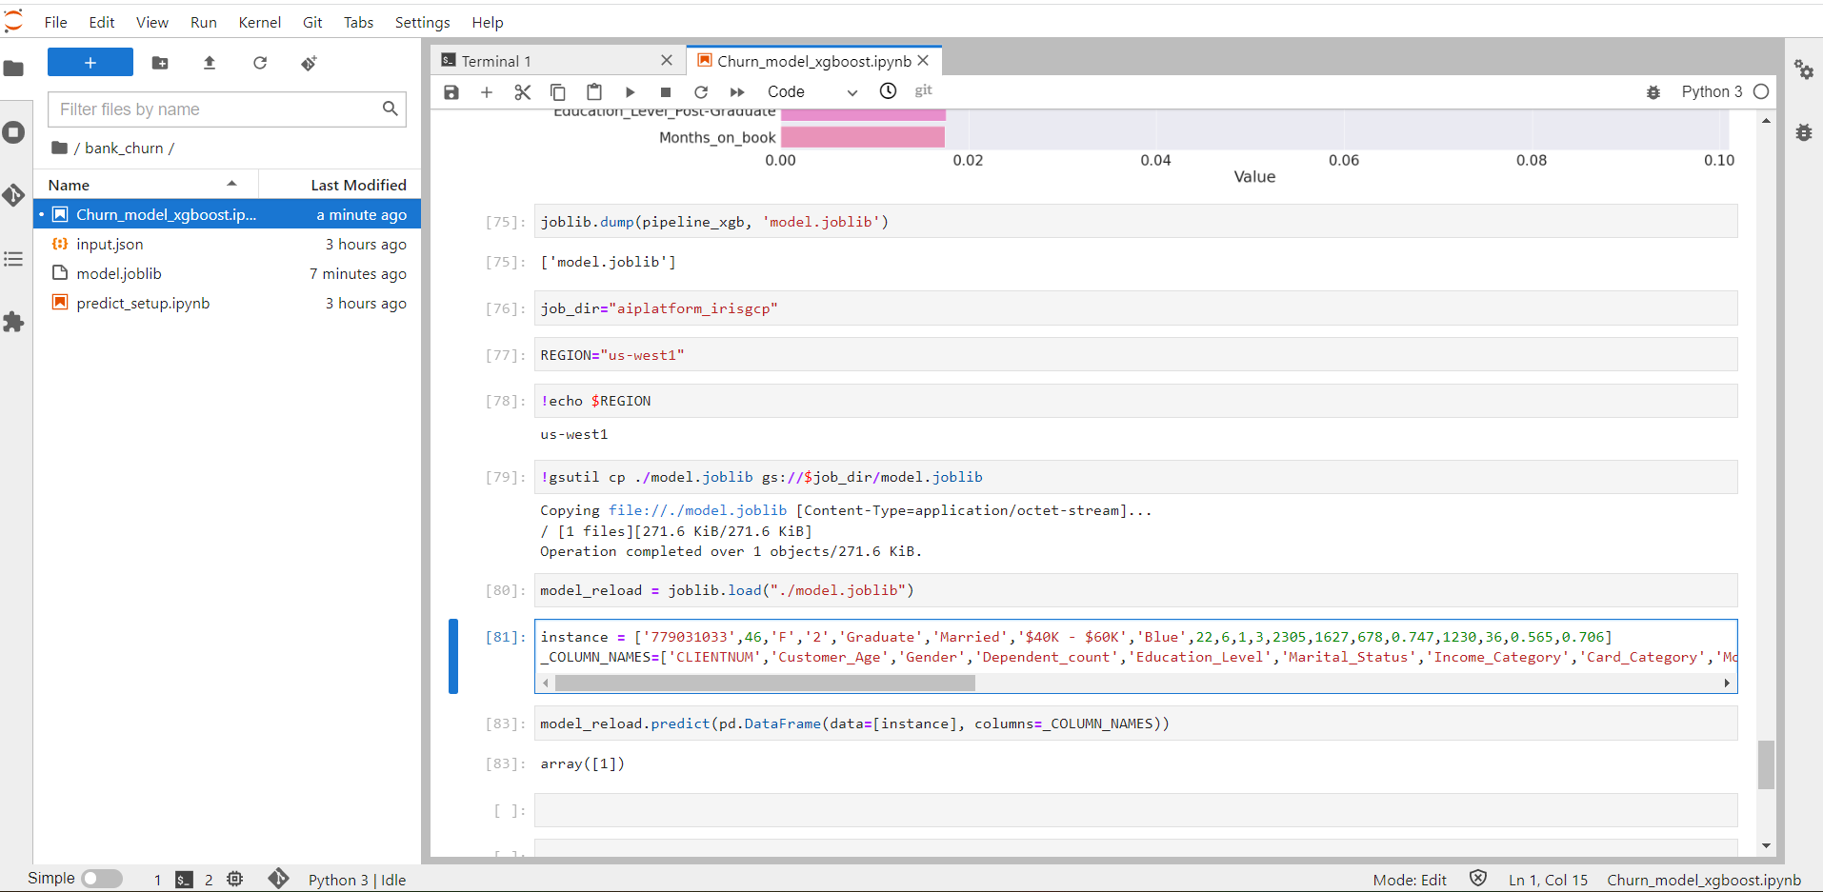

Alright model is saved. Now how to deploy?

GCP already provided a standard code ofr customized preictors. It is in setup_pred.py in bank chrner folder

Create a class which have methods to predict from a saved model -> Save that class I .py file and test it -> provide all the dependent packages (its better to provide dependent packages always to avoid version issues)

Follow final codes in AIPLATFORM_bank to understand more

The below code save the model in AI platform models

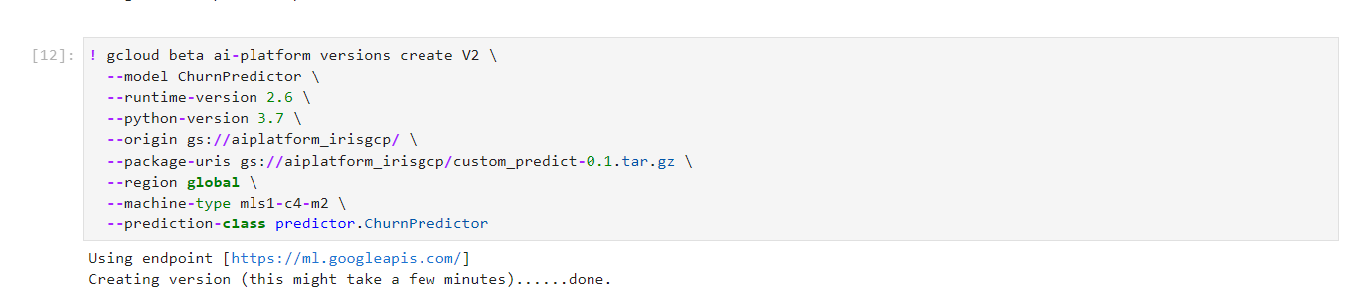

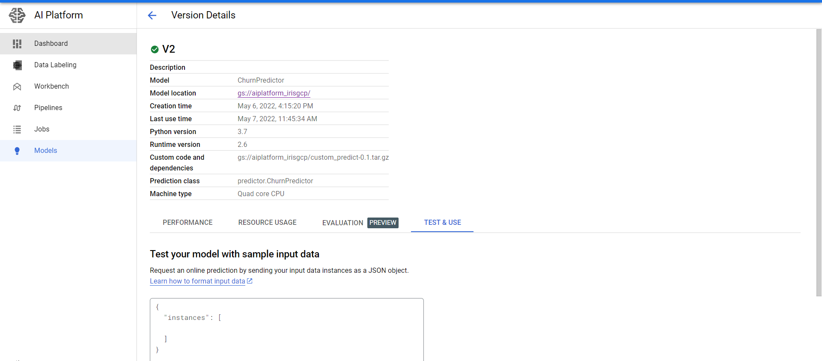

**We can deploy the custom predictor in the same way as we did before in AI platform Iris_pred.py**

**AI PLATFORM** **JOBS**

How to leverage jobs to train and deploy models.

Provides the dependicies that are required to train ML models using hosted frameworks. It supppots custom containers, parallel distributed training. We can build code on our local machine and submit job for training in GCP

We will work on tensorflow package – Create a notebook under tensorflow package

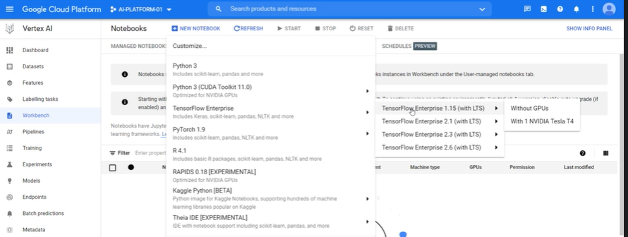

Use the data AIPLATFORM_jobs insurance.

Utils.py -- contains code to read the data from cloud storage and preprocess it

Model.py – build skeleton of model and feed data to model

Task.py – run and train the model

Check the code running locally and submit a job. Its tricky that’s why refer to video whenever we require it

**AI PLATFORM PIPELINES**

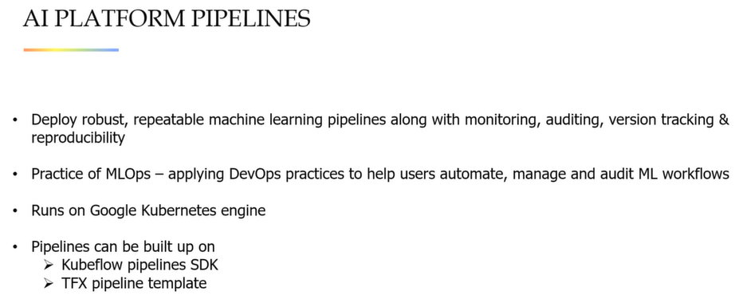

**What’s the difference between container, docker and kubernetes?**

Code is working fine on our system but not in other system or in production system. It may be due to change in os or versions or any other reason.

**Container helps us to overcome the problem of portability which separates the code from underlying infrastructure on which its running.**

Developers can package their application including all of the libraries into **small images called containers**. They can run on any machine which has containerized platform. **DOCKER is one of the most popular containerized platform**

When we say docker we are talking about docker engine – the runtime that allows us to build and run the containers. We need to build a docker container with help of docker file before running it.

**Kunernetes is an open source container management platform that unifies cluster of machines into single pool of compute resources**. **With kubernetes we can organize applications in group of containers which runs using the docker engine so the application runs as per user request**

**CODE -> CONTAINER >DOCKER ->KUBERNETES**

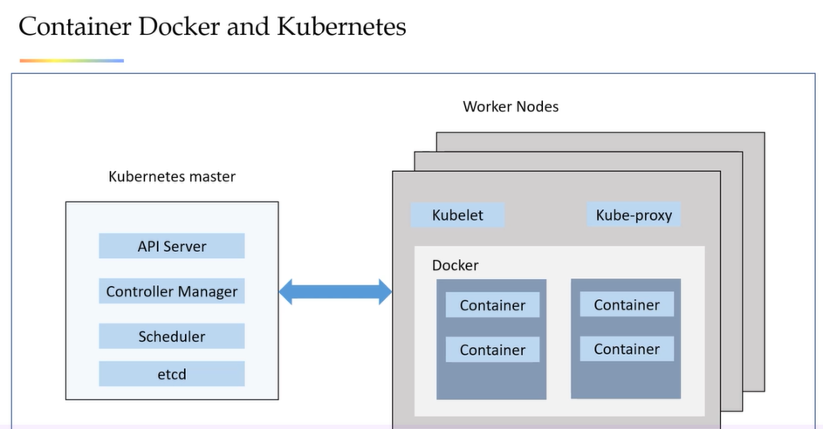

**Building docker image on GCP**

Enable APIS

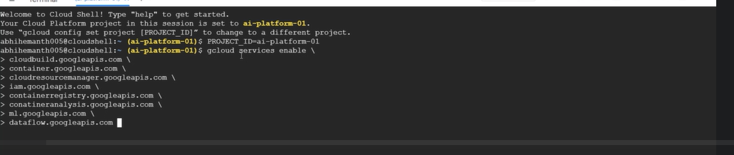

All the APIS are enabled. Now we have to make sure that cloud built service account have editor access in the project so lets enable it.





Now create a folder which contains docker file, requirements.txt file.

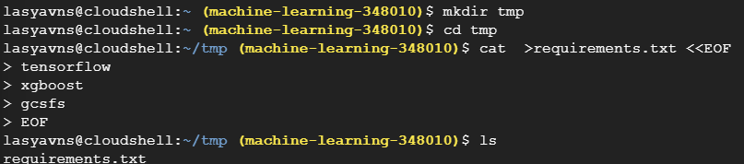

**Instead of creating docker image from scratch, we will be downloading from below link and make all the updates, copy, install all packages and place it back in the registry. Our case we will be using container registry from gcp itself**

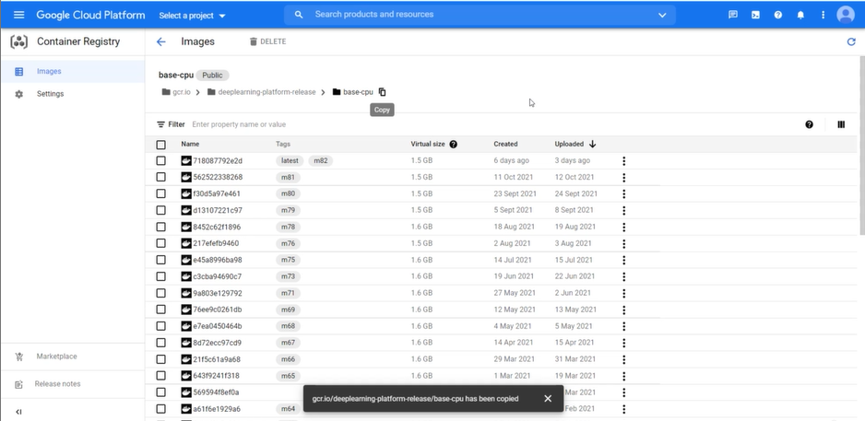

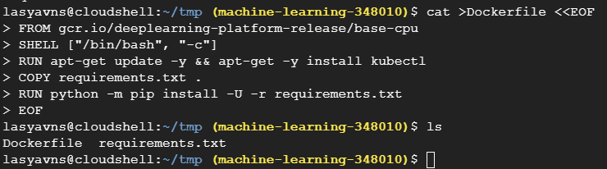

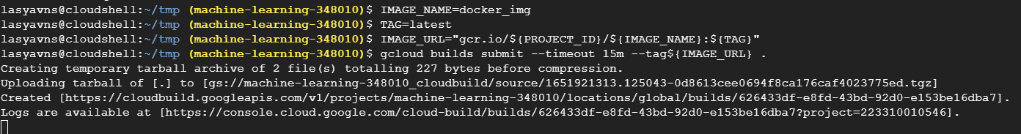

Image will be created by copying the files, updating the required things and installing the packages mentioned in requirements.txt file

We created an image and saved it in our container registry

**Now let’s create a compute engine to work on python using this docker image. We can still do it using GUI no need of these commands**

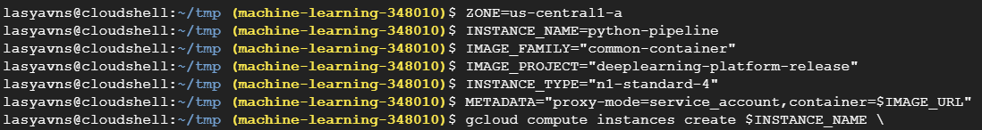

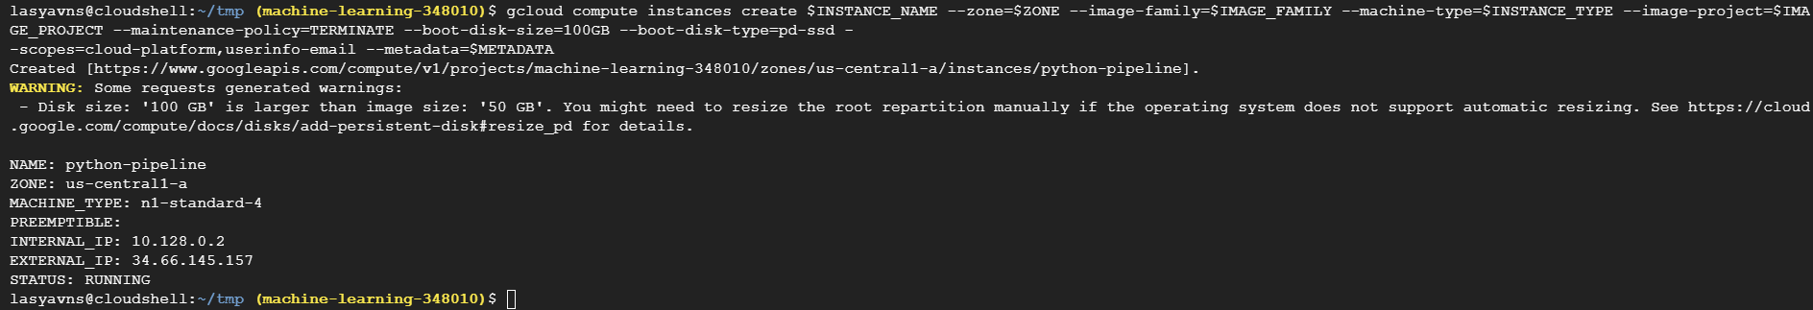

VM Created and reflected in AI platform notebook as well

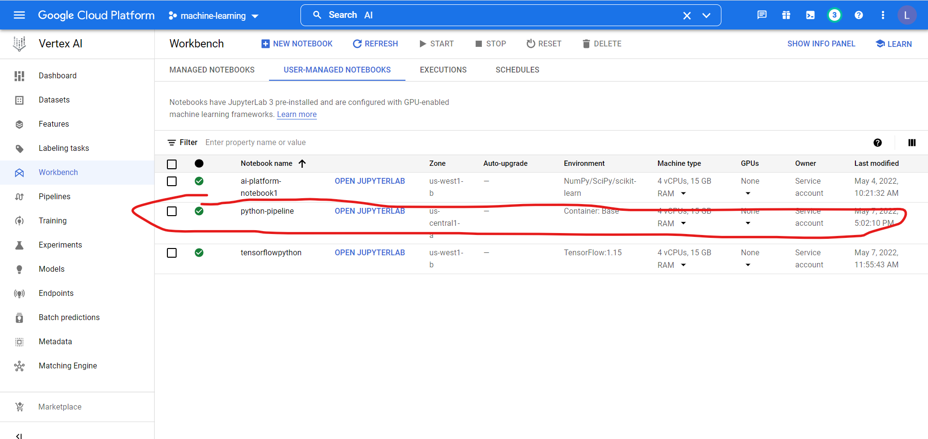

Data saved in big query table and will be accessed by code. Good videos on udemy will download and arrange them.

**VERTEX AI**

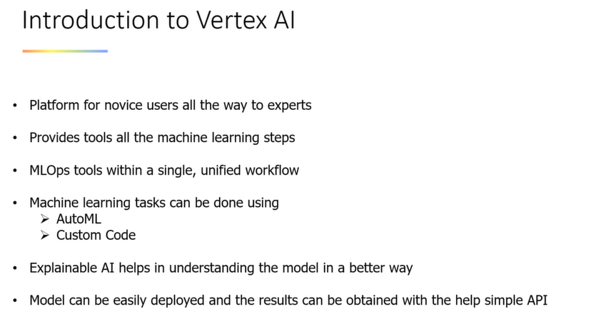

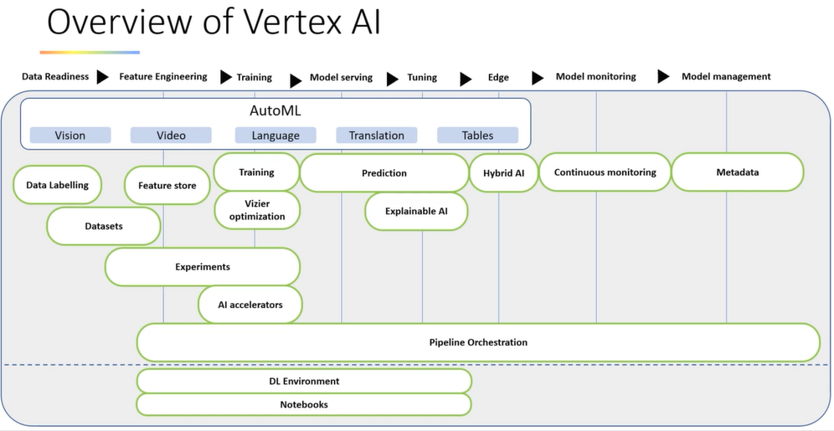

**VERTEX AI – Auto ML**

Creation of dataset

Vertex AI -> On left column click on Datasets -> Create Dataset -> Give it a name -> Region -> Select upload option **(Remember when the data source changes it will be directly reflected in vertex ai data set)**

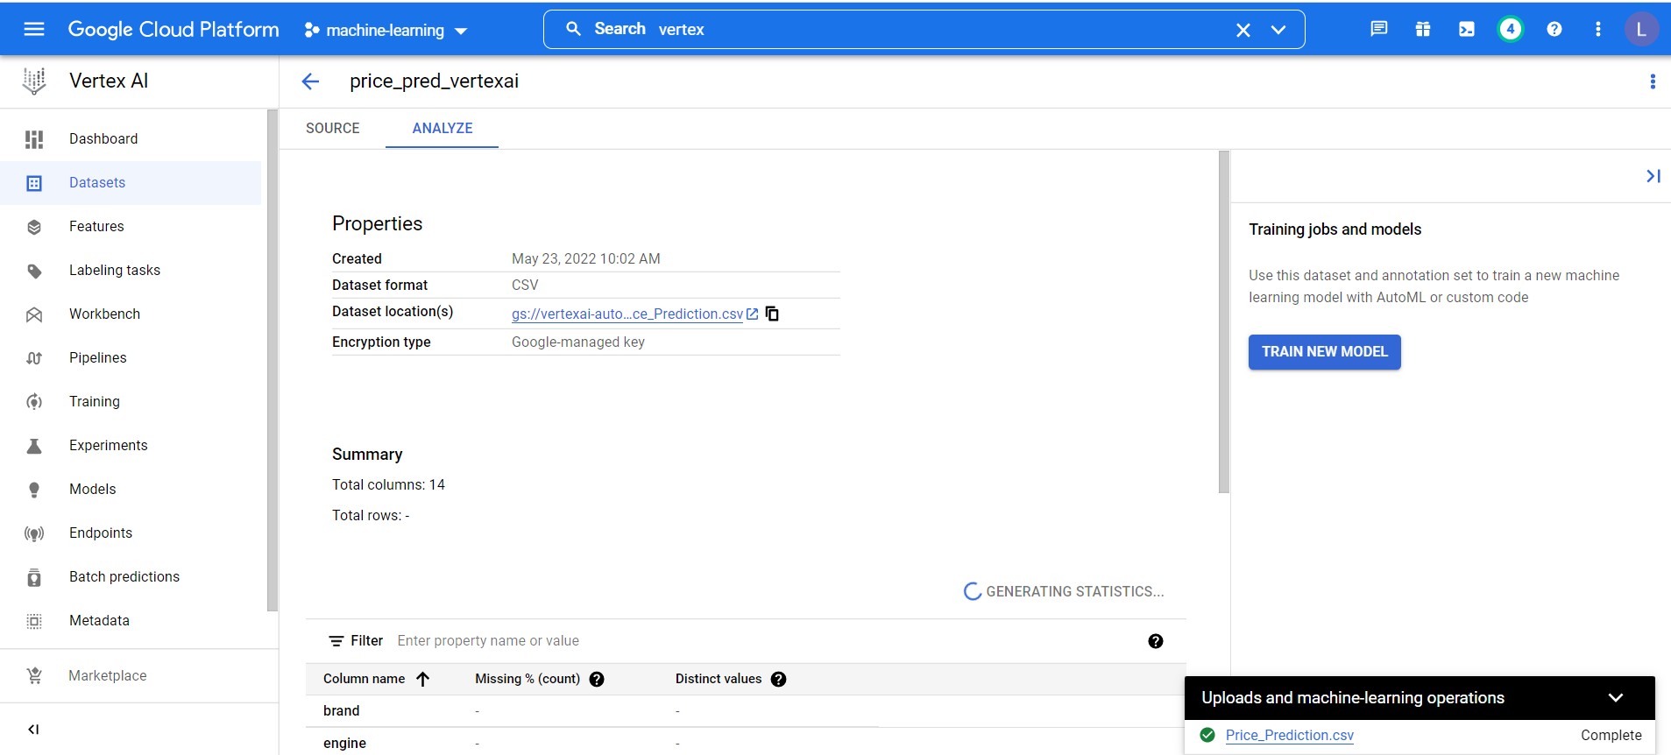

Then click on train new model -> selective objective(classification/regeression) -> select target column -> verify all column types are taken correctly -> PRection metric -> training hours -> and start very similar to AutoML

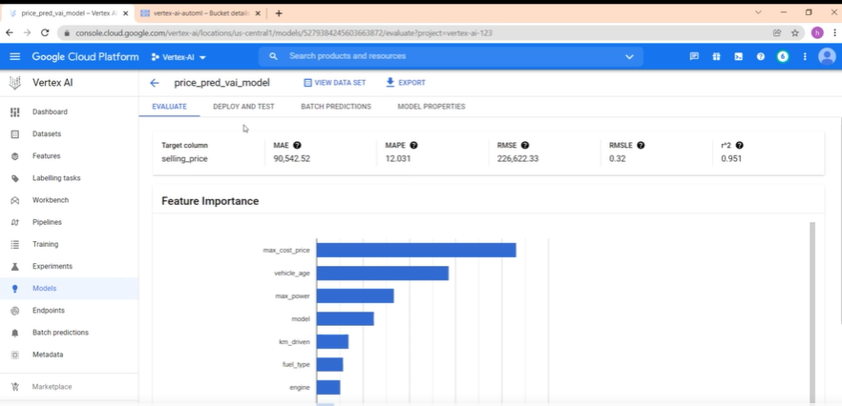

Before deploying we can use batch prediction to make predictions in cloud itself

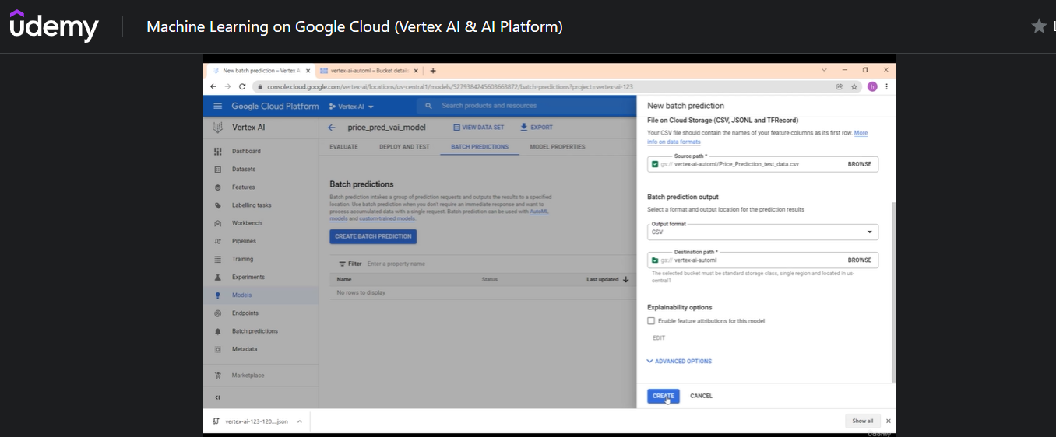

We have deployment options

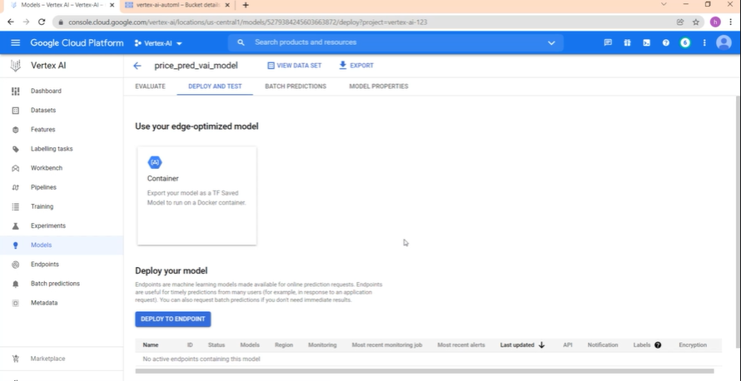

Once endpoint is deployed we can access it via API using service account. Similar to what we did before.

**VERTEX AI Docker** custom model prediction

Download crab age prediction data from kaggle and store it in cloud storage

Open vertex -> click on workbench -> Create notebook instance ->

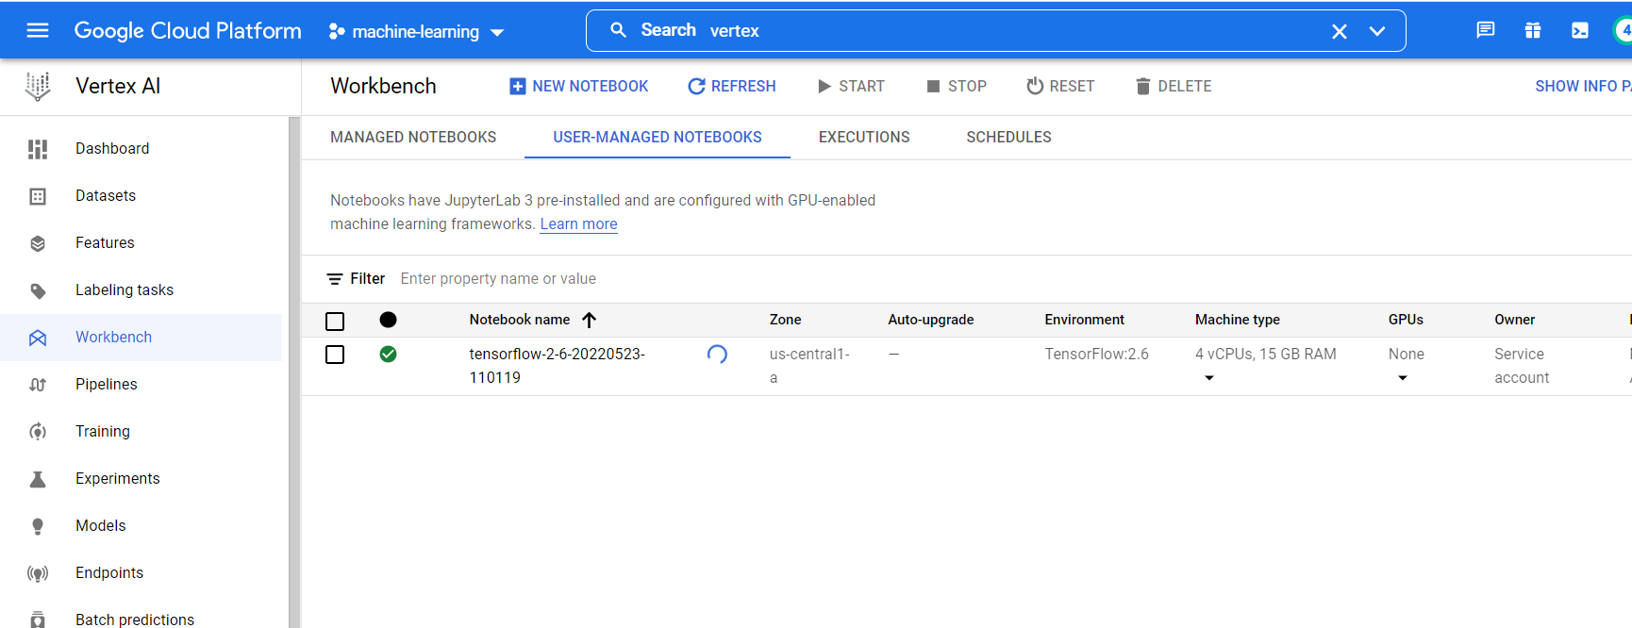

Open jupterlab -> Open terminal -> Create a folder and a create a docker file in that folder

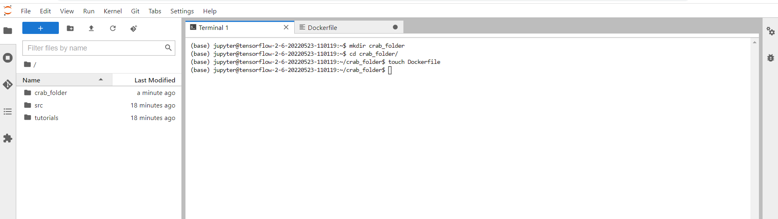

Open dockerfile and start typing

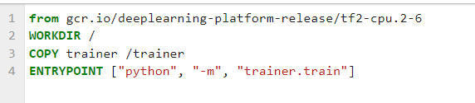

Now lets create a bucket to save the trained model

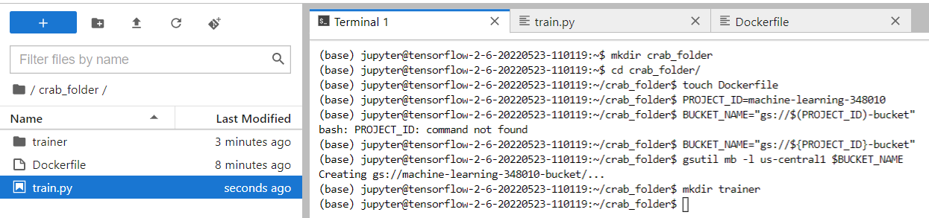

Once bucket is created, upload crab precition data into that bucket and open train.py file

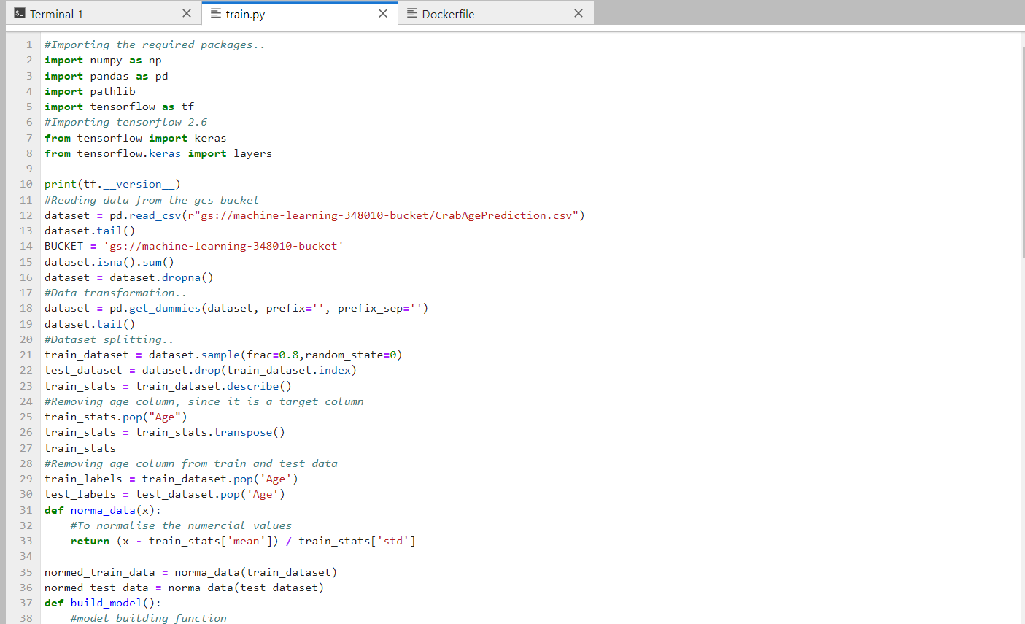

Lets start creating docker image

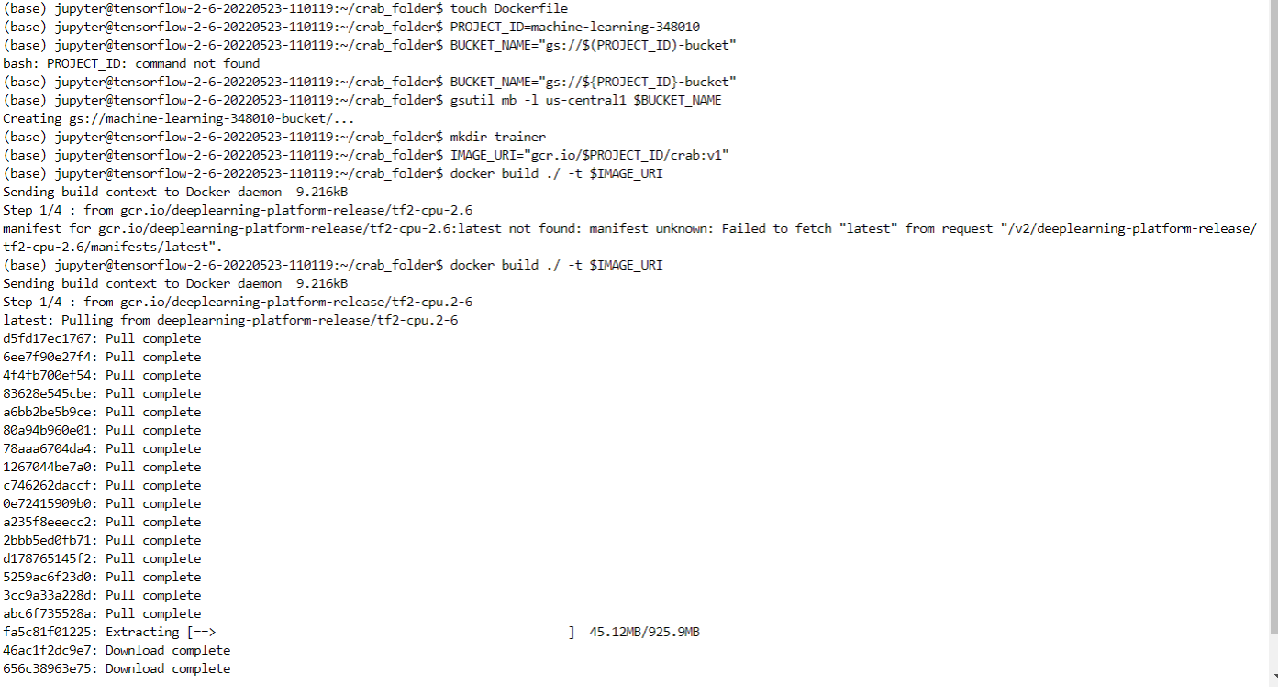



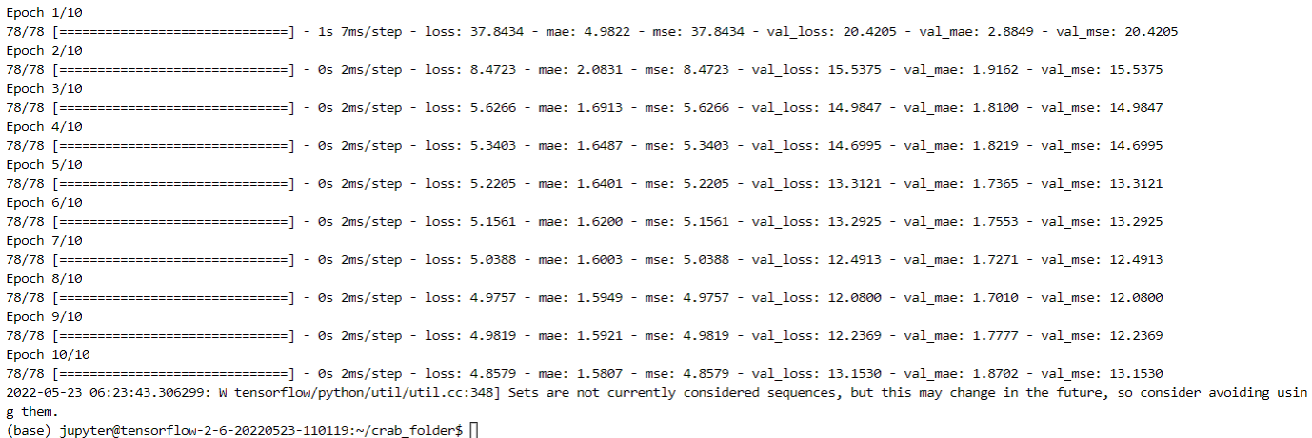

Image is build and saved in container registry

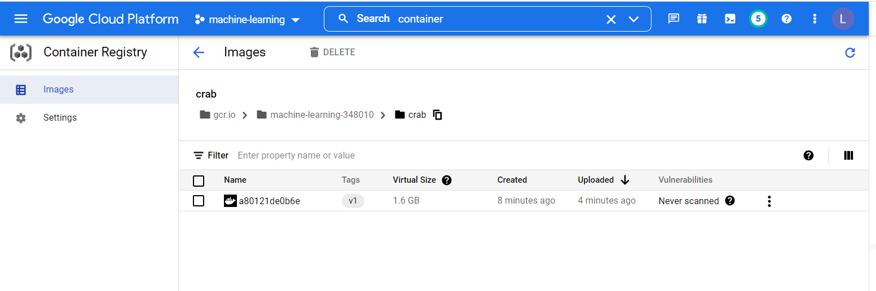

Now lets use docker image to train the models

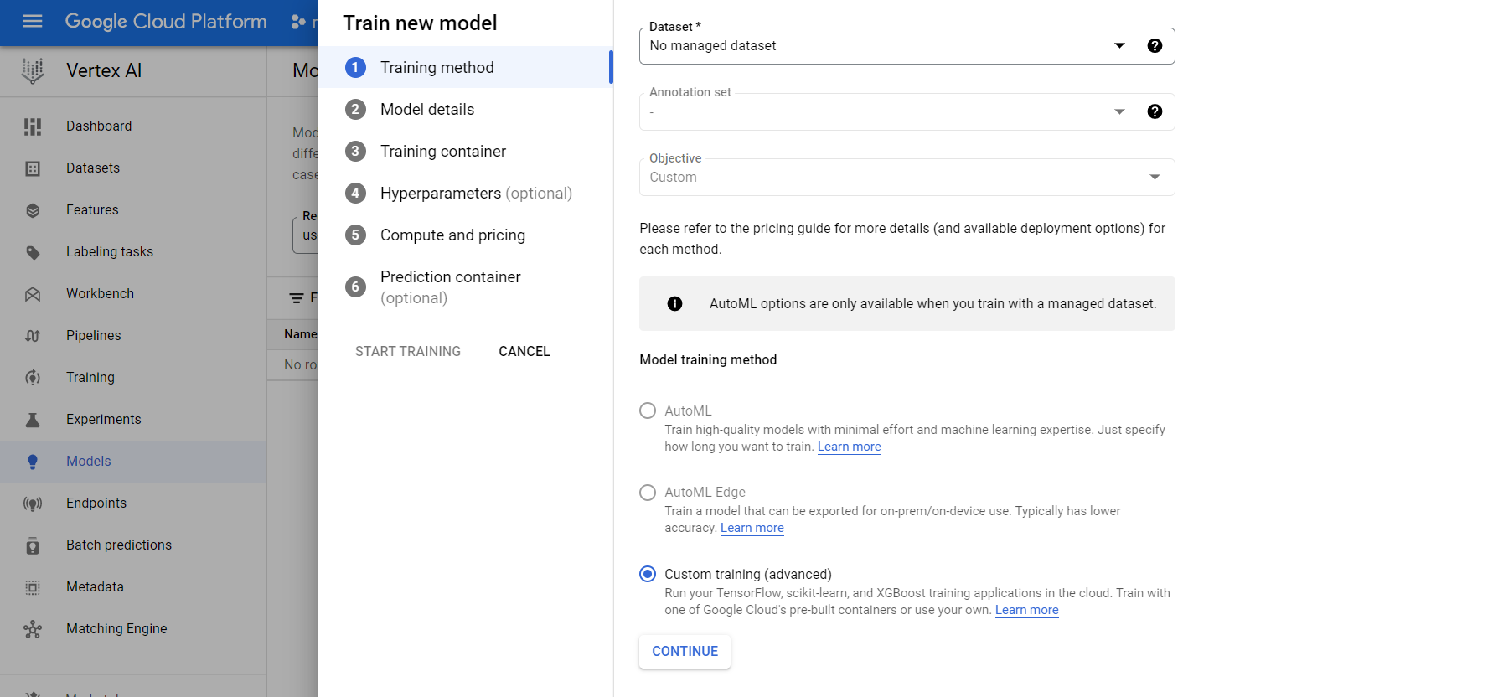

Once model is rained, create an endpoint and use that endpoint API for predictions

**Hyperparameter Tuning**

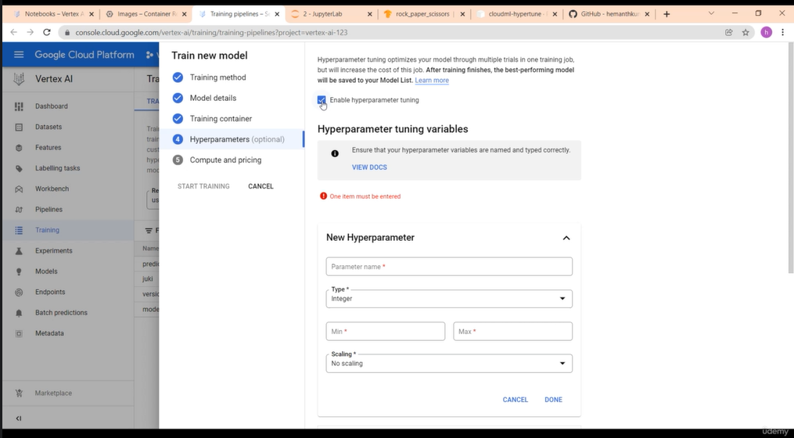

**All steps are same as as docker one except above image where we selct the option of hyperparameter tuning.**

**We can perform training job using python SDK as well**

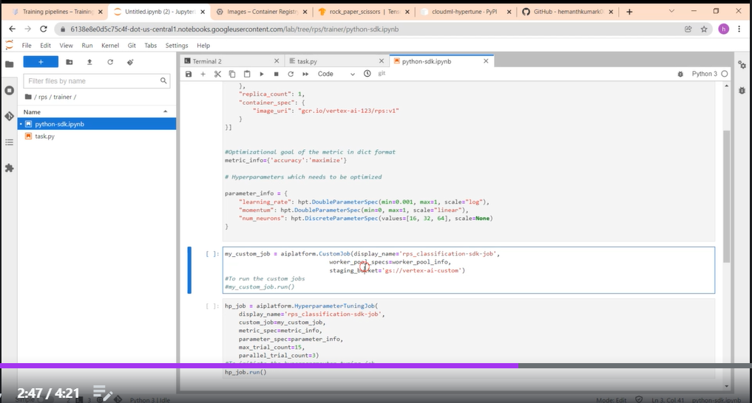

**PIPELINES OF VERTEX AI _ CUSTOM**

We will create kubeflow pipline to create a dataset, train a model and if it pass a threshold deploy it.

RUN a jupyternotebook which creates pipelines, create models and deploy it to end point

**Vertex_AI_custom_train_pipeline-sasi.ipynb**

**VERTEX AI_FEATURE STORE**

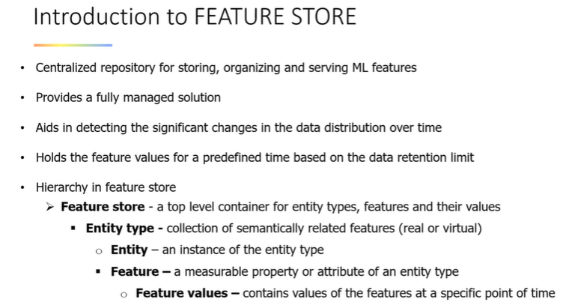

**Use churner data. Vertex AI -> On left tab features -> Create new feature store**

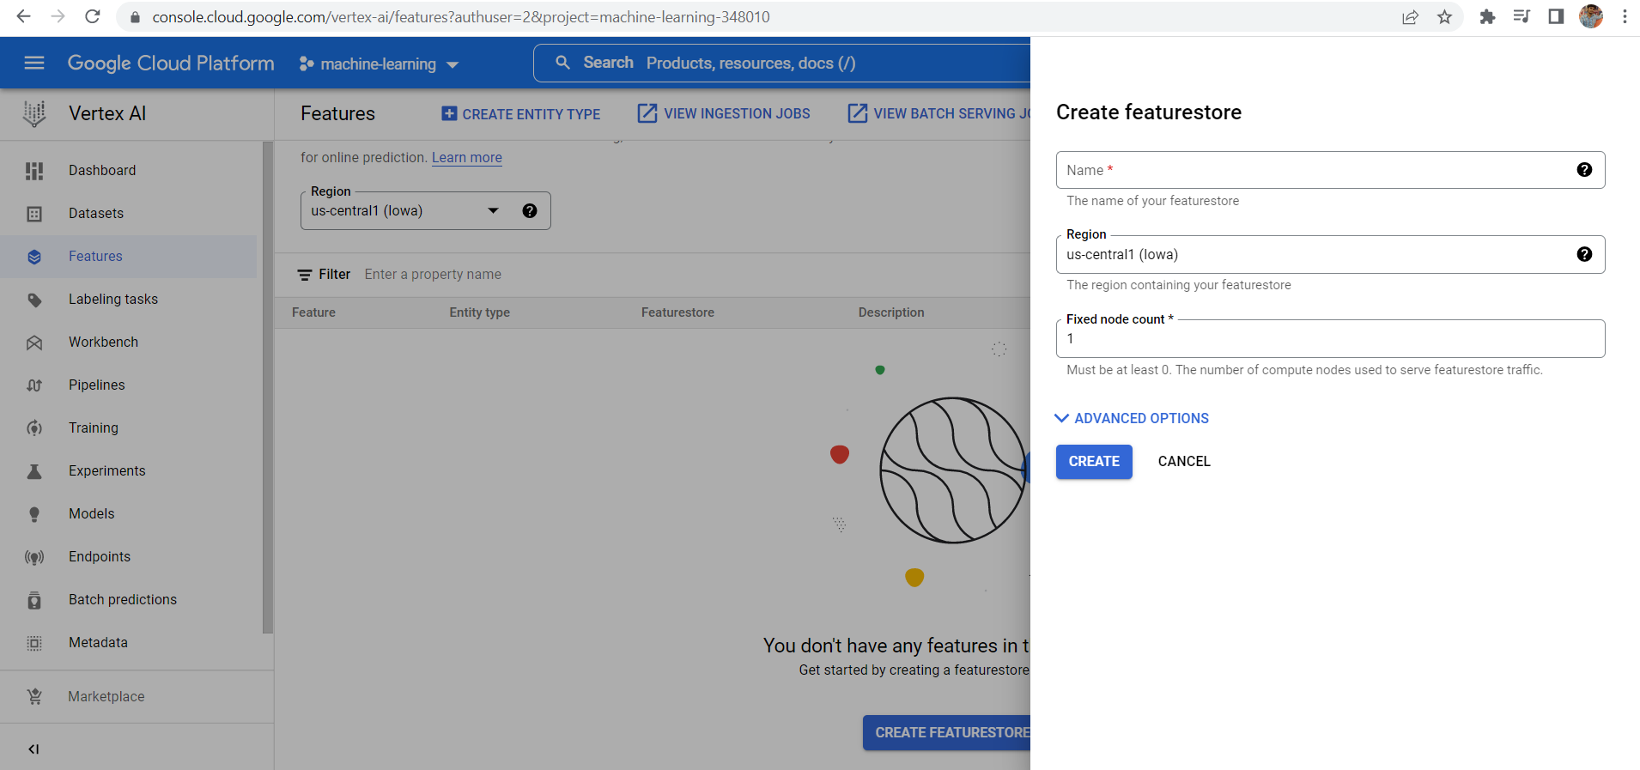

Create entity type – demography, credit score, race, etchnicity, eploymeent and so on

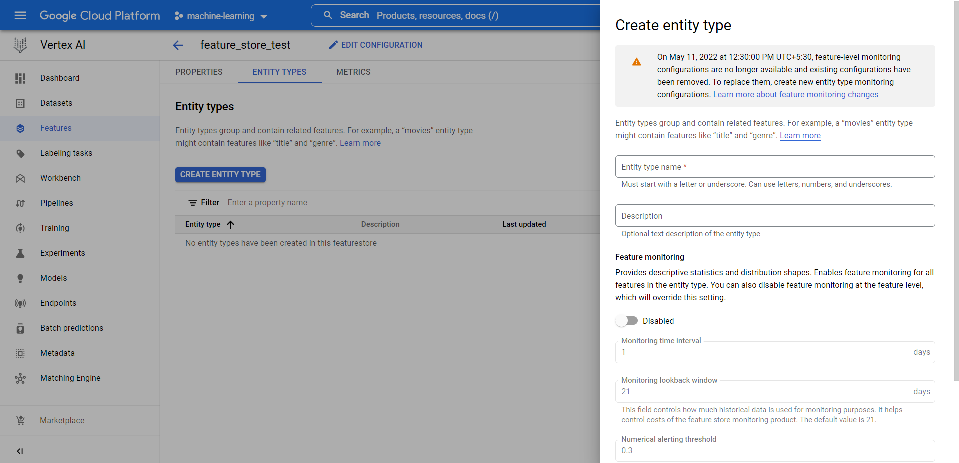

After entity created -> click on it and enter some features

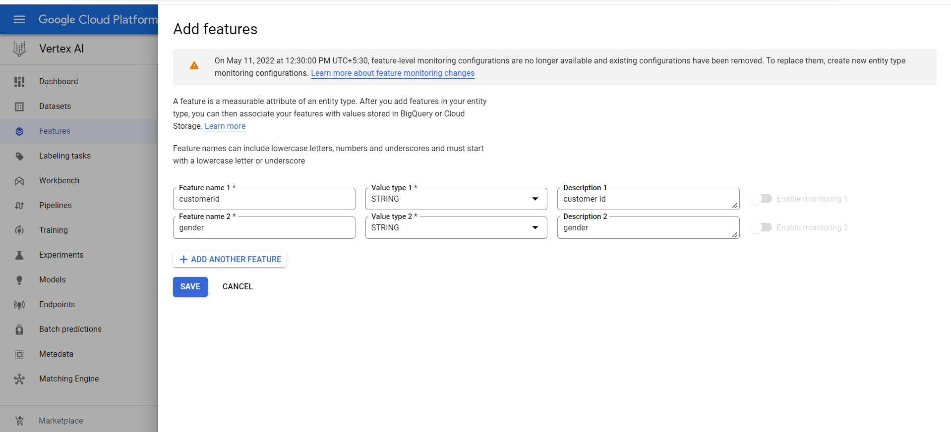

Once features are created we can ingest values – from a csv, excel file database

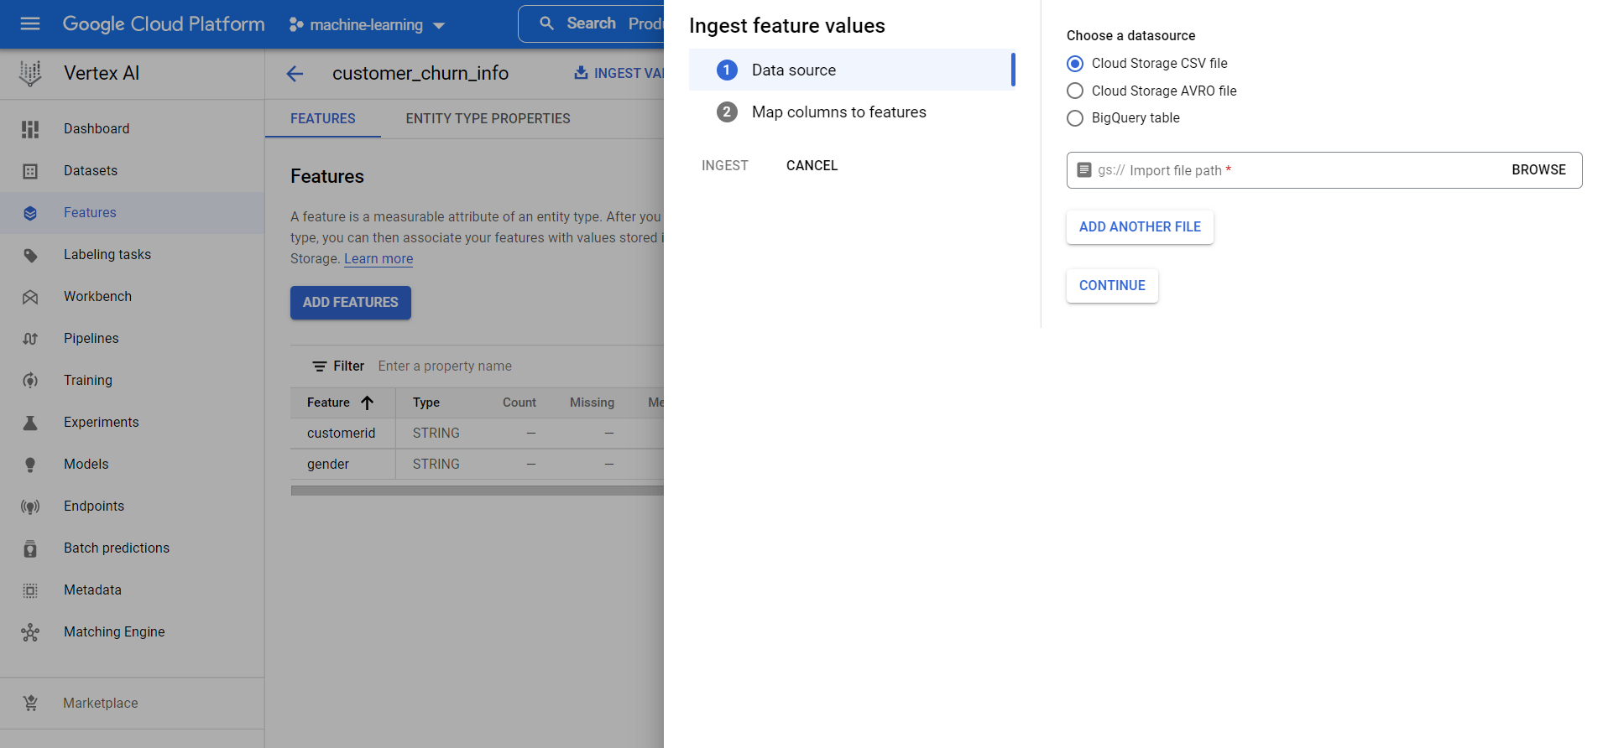

We can ingest values like below

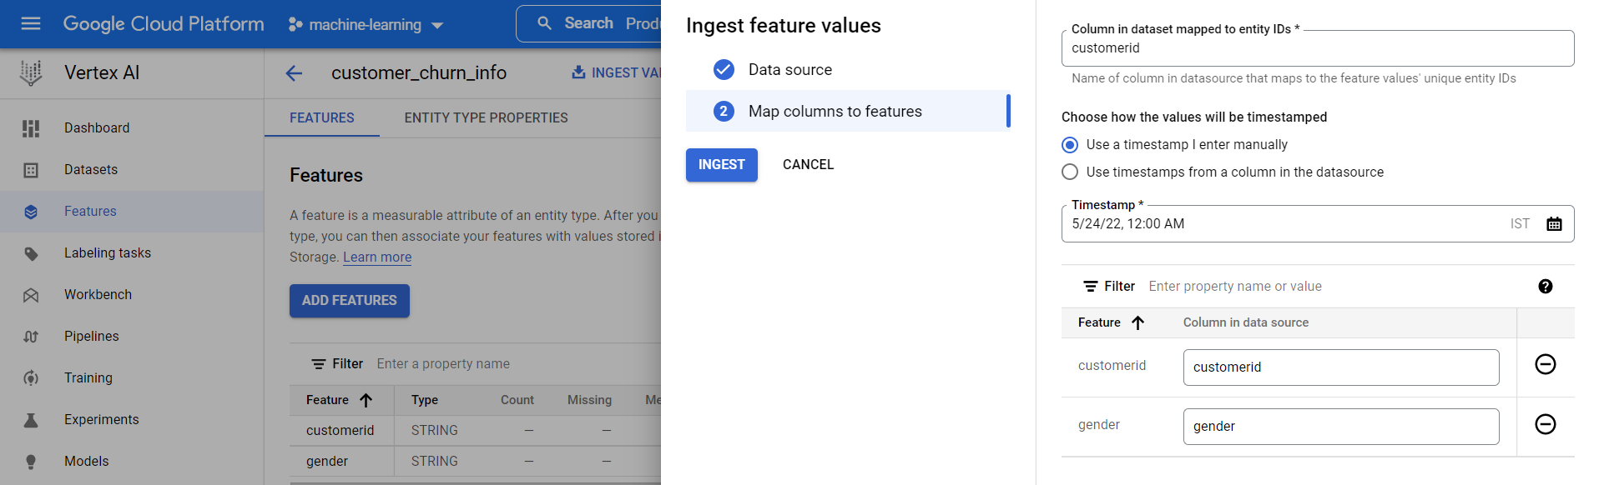

But let’s see how we can do with python SDK - **vertex-ai_feature-store.ipynb**

SUMMARY